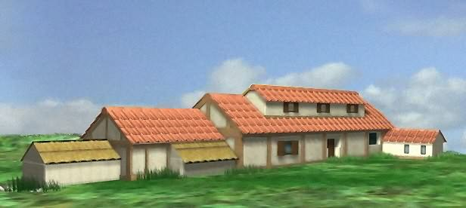**For Sale** – ROMAN VILLA Name………………………………

Main

Bedroom

cubiculum

Bedroom

(cubiculum

Bedroom

cubiculum

Living Room(Tablinium)

larder

Kitchen

(culina)

Servants’

Bedroom

cubiculum

Corridor (atrium)

Veranda

Dining Room

(triclinium)

Bathhouse

Courtyard and Garden

Herb Garden

………………………………………………………………………………………………………………………………………

………………………………………………………………………………………………………………………………………

………………………………………………………………………………………………………………………………………

………………………………………………………………………………………………………………………………………

………………………………………………………………………………………………………………………………………

………………………………………………………………………………………………………………………………………