Anglo Saxon History Lesson 5: Religion and Gods

Use the information on the PowerPoint to try and answer the questions on the table below. See you how much you can remember first!
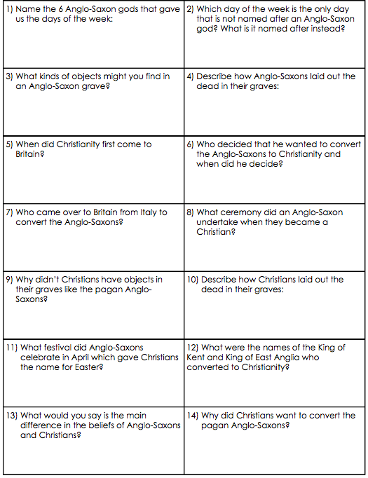

Extension Work:

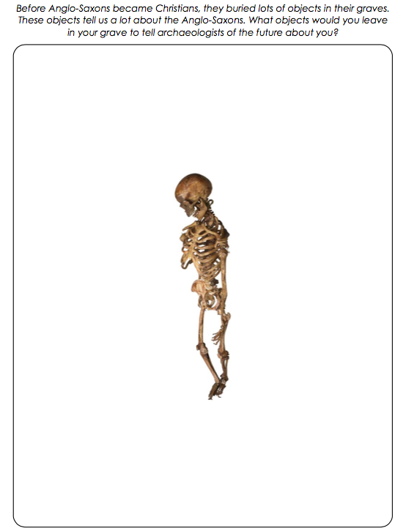
Remember what you have learnt about different types of soils and materials that survive over time to help you think carefully about what you could put in.

