Lesson 1

Look at this image of Shackleton and some of his team dressed for the Antarctic weather. They came together as a team to discuss the equipment and supplies they would need.
Make a list for the following:
Transport
Equipment
Food
Clothing

Remember that modern luxuries were not available at the time!
Also, there is no infrastructure or amenities in the Antarctic.
Items must be essential, easy to store and light to carry. Please think about foods for energy, layers for warmth, medicine, food for animals and shelter.

We do not have enough ponies and huskies to carry these supplies and they will have to be cut back by 50%. This task will involve pupils in a deeper discussion of the essentials needed for survival. They will be using negotiation and reasoning skills to justify their choices.

Lesson 2 and 3

Each team member on the expedition was allowed to take 1kg of personal supplies. Put together a box of personal supplies.
It must not weigh more than 1kg.
Write a poem based on 'The Magic Box' by Kit Wright (beginning 'I have put in my box...')

Shackleton put a diary in his personal box and wrote in it every day during the expedition. This helped him to tell the world found out what happened on the expedition.

Kit wright performing his poem

The Magic Box
Kit Wright
I will put in the box
the swish of a silk sari on a summer night,
fire from the nostrils of a Chinese dragon,
the tip of a tongue touching a tooth.
I will put in the box
a snowman with a rumbling belly
a sip of the bluest water from Lake Lucerne,
a leaping spark from an electric fish.
I will put into the box
three violet wishes spoken in Gujarati,
the last joke of an ancient uncle,
and the first smile of a baby.
I will put into the box
a fifth season and a black sun,
a cowboy on a broomstick
and a witch on a white horse.
My box is fashioned from ice and gold and steel,
with stars on the lid and secrets in the corners.
Its hinges are the toe joints of dinosaurs.
I shall surf in my box
on the great high-rolling breakers of the wild Atlantic,
then wash ashore on a yellow beach
the colour of the sun.

Lesson 4 – Transport
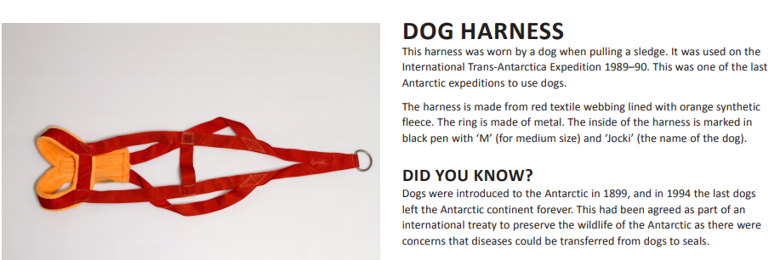

Activities:

