Wednesday 1st July
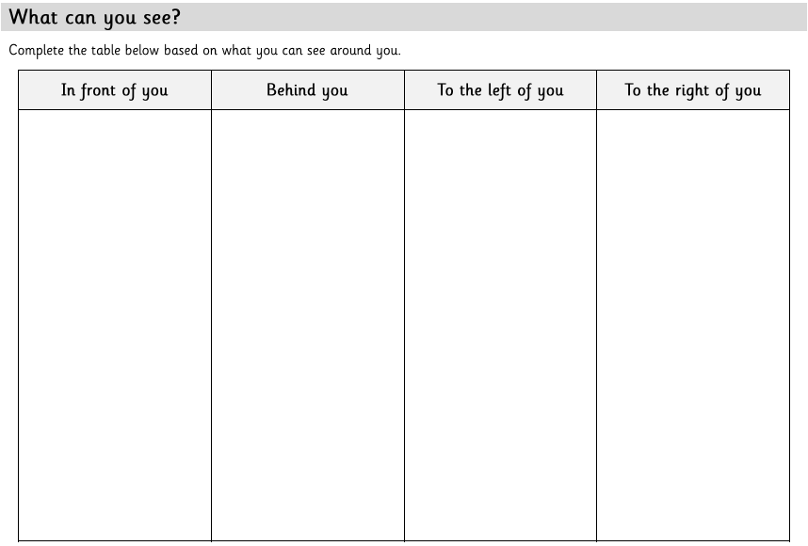
LO: To describe position, direction and movement using direct comparison

Task 1:

Task 2: use their table to create sentences such as:

The _____ is above the _____. The __ is below the _____.
The _____ is to the right of the _____. The _____ is to the left of _____.
In between _____ and _____ is _____. There is nothing in between _____ and _____.

