**Weather Watch**

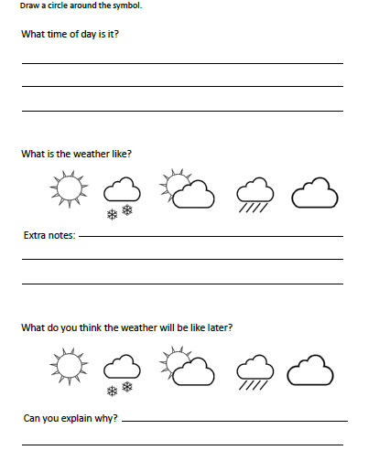

What season are we in?