L.O. To be able to calculate the volume of cuboids and cubes using the formula volume = length × width × height or v = l x w x h.

Main Teaching

Teaching
- Look at the rectangle below, this is a 2D shape. It is known mathematically as a shape on a plane as it is flat. What is the formula we use to calculate the area (remember we have already worked on this in class)?
- Answer: area = length × width or A = l × w. The area is the number of squares the flat shape covers, therefore the area of the rectangle is 5 × 4 = 20 squares.

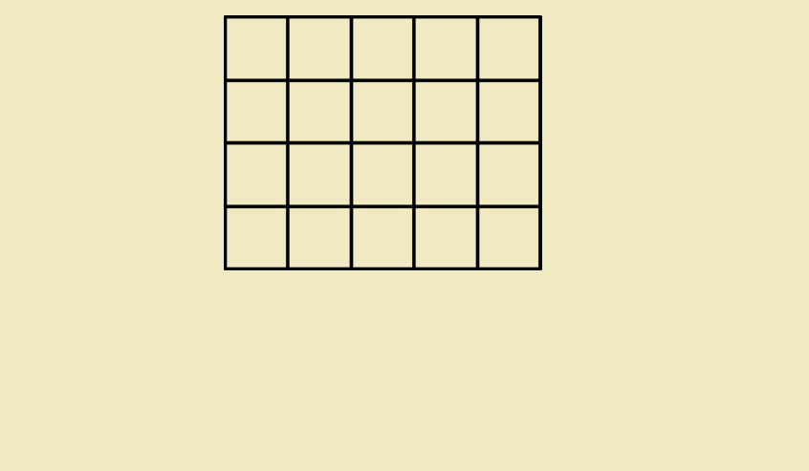
Now look at this shape.

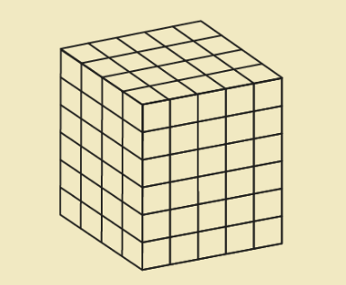

- How would you describe this shape?
It has six faces (not sides) and six vertices (not corners), it has eight edges, it is a 3D shape called a cuboid.

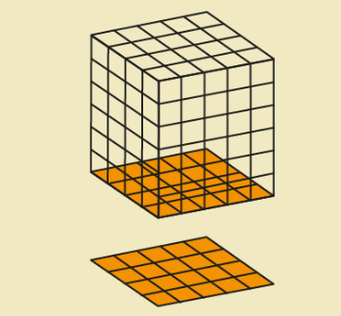
- The cuboid has a base which is a rectangle. The length and width is a 5×4 rectangle.

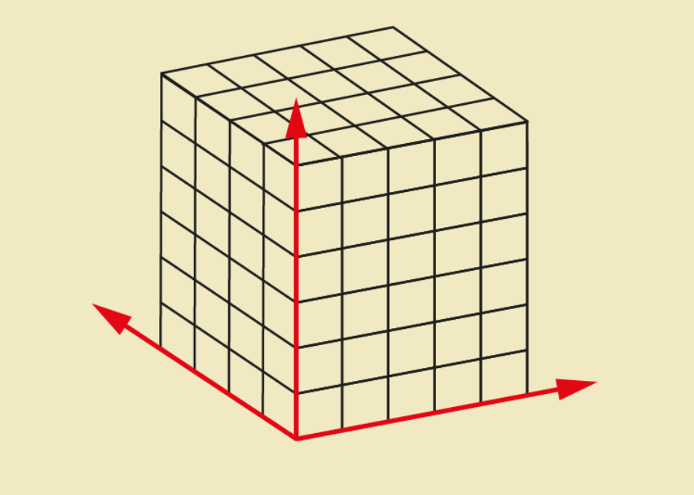
- The cuboid also has a height because it is a 3D shape. We can calculate the volume of the cuboid. This means how many cubes (not squares) it takes up in three dimensions: length, width and height. We calculate the volume of a cube or cuboid by finding the area of the base and multiplying it by the height ,
volume = length × width × height.
This is measured in units cubed so cm³, or m³, or mm³, or even km³ if it is truly massive. This formula can be written as v = l × w × h.

- Look back at the cuboid. The length is (5 cm), the width (4 cm) and the height is (6 cm) so it has a volume of the area of the base × the height :

5 cm × 4 cm = 20 cm²
20 cm² × 6 cm = 120 cm³
(cm² × cm = cm³).
Volume = 120 cm³
The area is the space covered in two dimensions (length and width), so it is measured in square units cm². Volume is the space occupied in three dimensions (length, width and height), so it is measured in cubic units cm³.
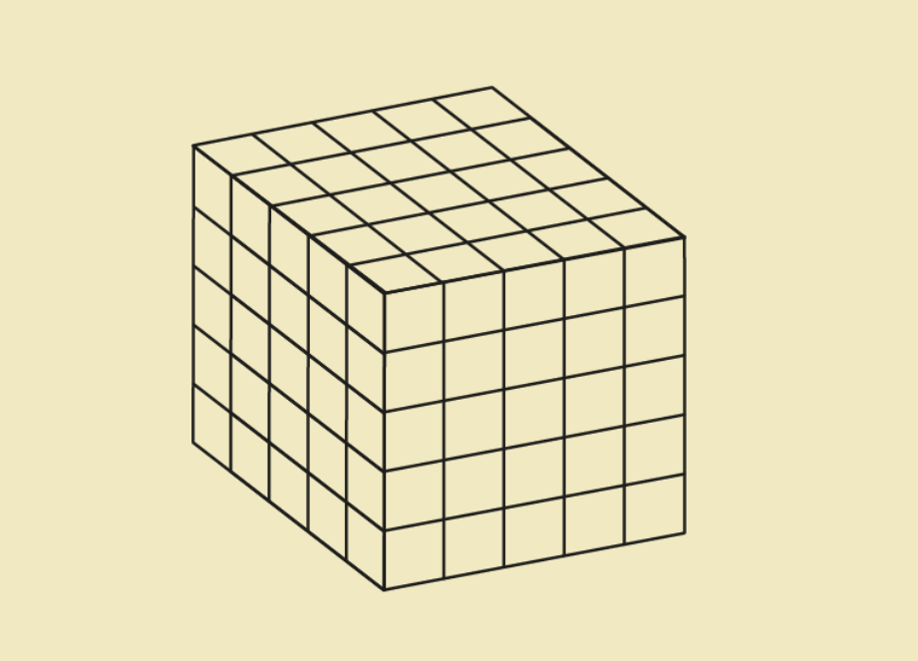

- Can you calculate the volume of this cube? First, find the measurement for the length, width and height. Next multiply the length x width (the area of the base). Finally multiply this answer by the height to find the volume. Formula v = l × w × h Record your calculation below. What is your answer?

We know the formula for the area of rectangles and now we also know the formula for the volume of cuboids. This means we can work out the volume of any cuboid or cube.
To revise your knowledge of the properties of cubes and cuboids you can watch this video:
https://www.bbc.co.uk/bitesize/clips/zsqmpv4

To reinforce your understanding of volume please watch this video:
https://www.youtube.com/watch?v=fw--FxHF6OA
Tasks
Now that you have practised how to find the volume of cubes and cuboids I would like you to complete the work below.
- If you feel that you need some practise complete worksheet Volume Task 1.
- If you are growing in confidence complete worksheet Volume Task 2.
- If you would like a challenge complete worksheet Volume Task 3 and Maths Mastery Checkpoint Volume.
You need to be confident in finding the volume of cubes and cuboids so if you feel that you need more practise complete more than one task.
S.C.
1. Have I found the correct measurements for the length, width and height of the shape?
2. Have I multiplied the length by the width, l x w?
3. Have I multiplied the answer by the height? v = l x w x h
4. Have I used the correct unit of measurement? e.g. cm³, m³

