‘Vase with Daisies and Poppies’, 1890 by Vincent Van Gogh

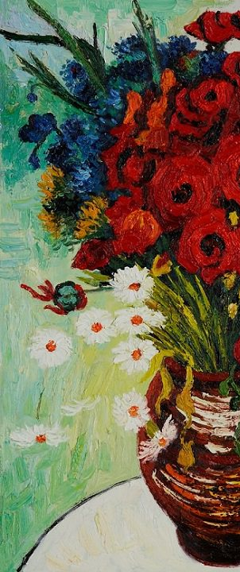
Oh no! This picture has accidently been chopped in half. The picture needs to be finished. Use your imagination and have a go at drawing the other half of the flowers in the vase. You can use crayons, pencils or pastels, anything you have at home.

