Triangles Work – Subtraction Fluency Questions
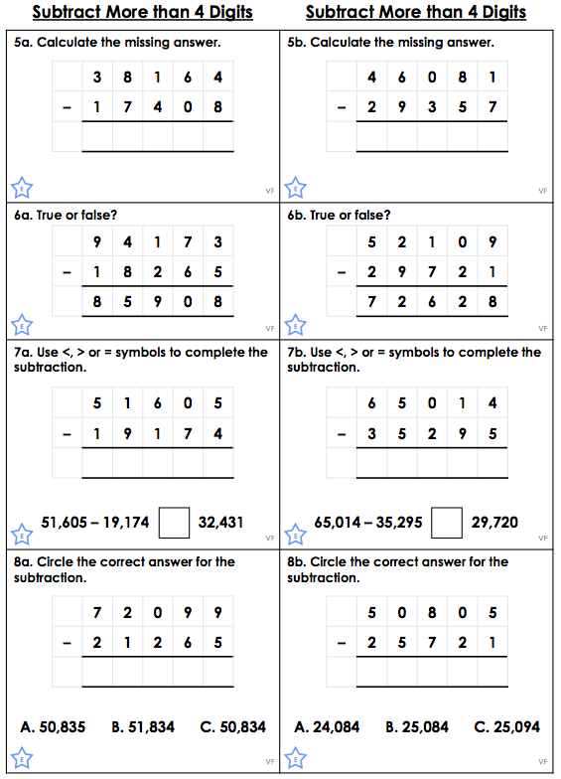

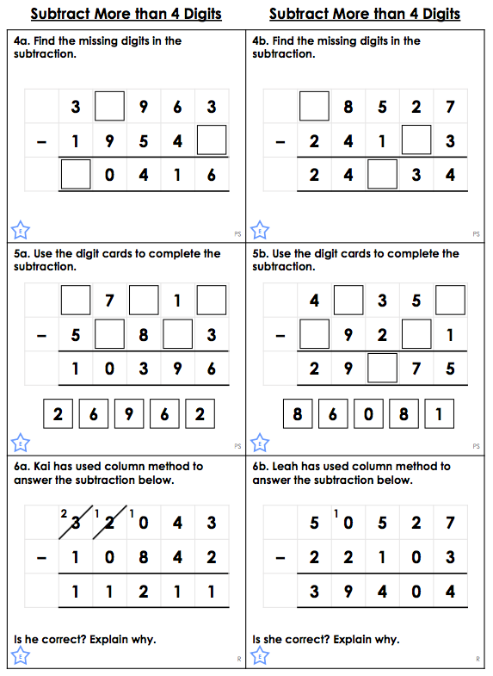
Triangles Work – Problem Solving Questions

Triangles Work – Answers

Fluency

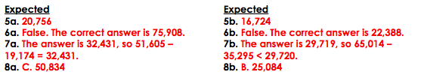

Problem Solving
