Triangles Work – Addition Fluency Questions
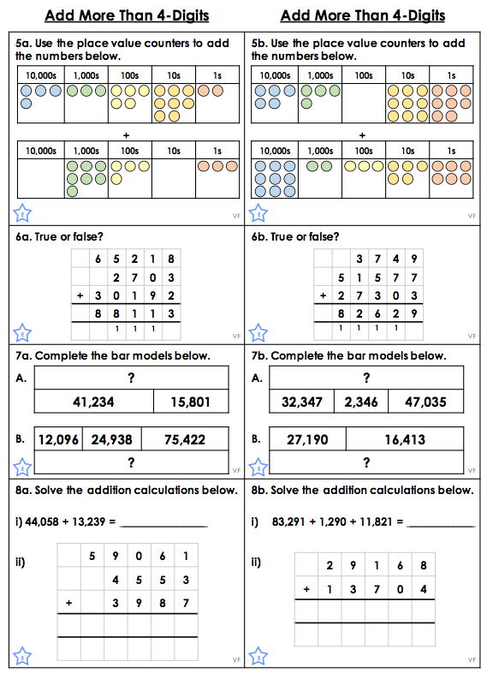
Triangles Work – Problem Solving Questions

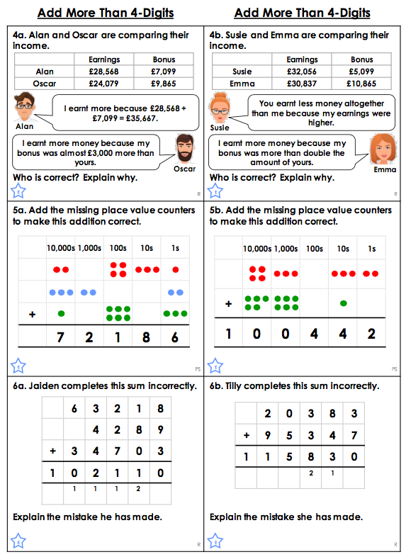

Triangles Work – Answers

Fluency
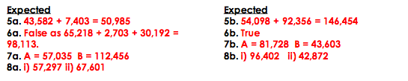

Problem Solving
