LO To be able to answer comprehension questions
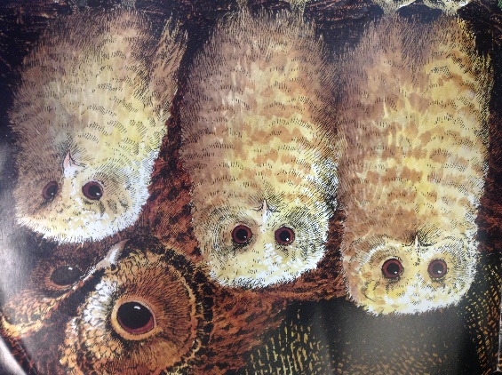
Once there were three baby owls: Sarah and Percy and Bill.
They lived in a hole in the trunk of a tree with their mother. The hole had twigs and leaves and owl feathers in it. It was their home.

1. What were the owl babies called?
_________ and ________ and __________.
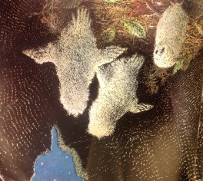
2. Where did they live?
In a wooden birdhouse.
.In a hole in the trunk of a tree.
In a nest at the top of a mountain.

(Owl Babies) Friday, 29th March, 2019

One night they woke up and their Owl Mother was GONE.
“Where’s mummy?” asked Sarah.
“Oh my goodness!” said Percy.
“I want my mummy!” said Bill.
Sarah thought that Owl mummy had gone hunting to get them some food.
They decided to wait outside the hole so they could look out for mother owl.
3. What happened when the owl babies woke up?
They had breakfast. Mother Owl was gone.
They got dressed. Sarah was missing.
4. What did Bill want?

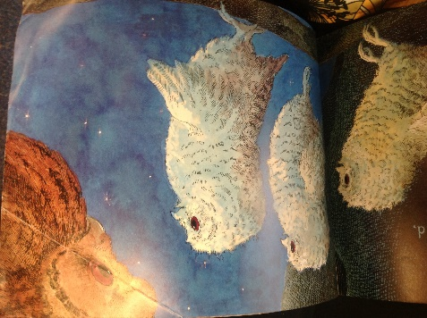
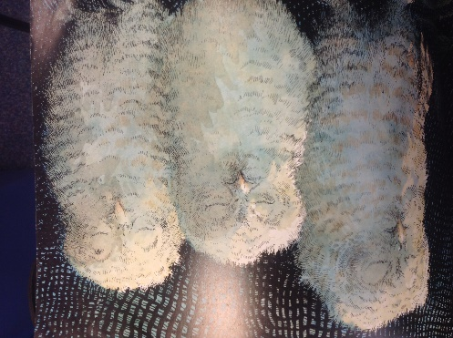
They waited and waited and waited in the cold, dark night. They had to be brave as they heard creatures moving around them.
They started to worry about Owl Mummy.
Sarah though she had got lost. Percy thought a fox might have got her. Bill cried. He wanted his mummy.

They closed their eyes and wished for her to come back.
5. Why did the owl babies have to be brave?
The sun was rising. Something was in their hole.
A wolf howled. There were creatures moving.

6. What did they think had happened to Owl Mother?
List two answers.
AND SHE CAME!
Soft and silent, she swooped through the trees to Sarah and Percy and Bill.

“WHAT’S ALL THE FUSS?” their Owl Mother asked. “You knew I’d come back.”
The owl babies thought about and they all knew she was coming back really.
“I love you mummy!” said Bill.

7. How did Owl Mother fly through the trees?
She fluttered through the trees.
She glided through the trees.
She swooped through the trees.

8. What did Bill say?
____________________________________________________________________________________________

