|  |  |  |  |  |
| --- | --- | --- | --- | --- |
| Poached Egg | Scrambled Egg | Boiled Egg | Fried Egg | Baking a Cake |
|  |  |  |  |  |
|  |  |  |  |  |

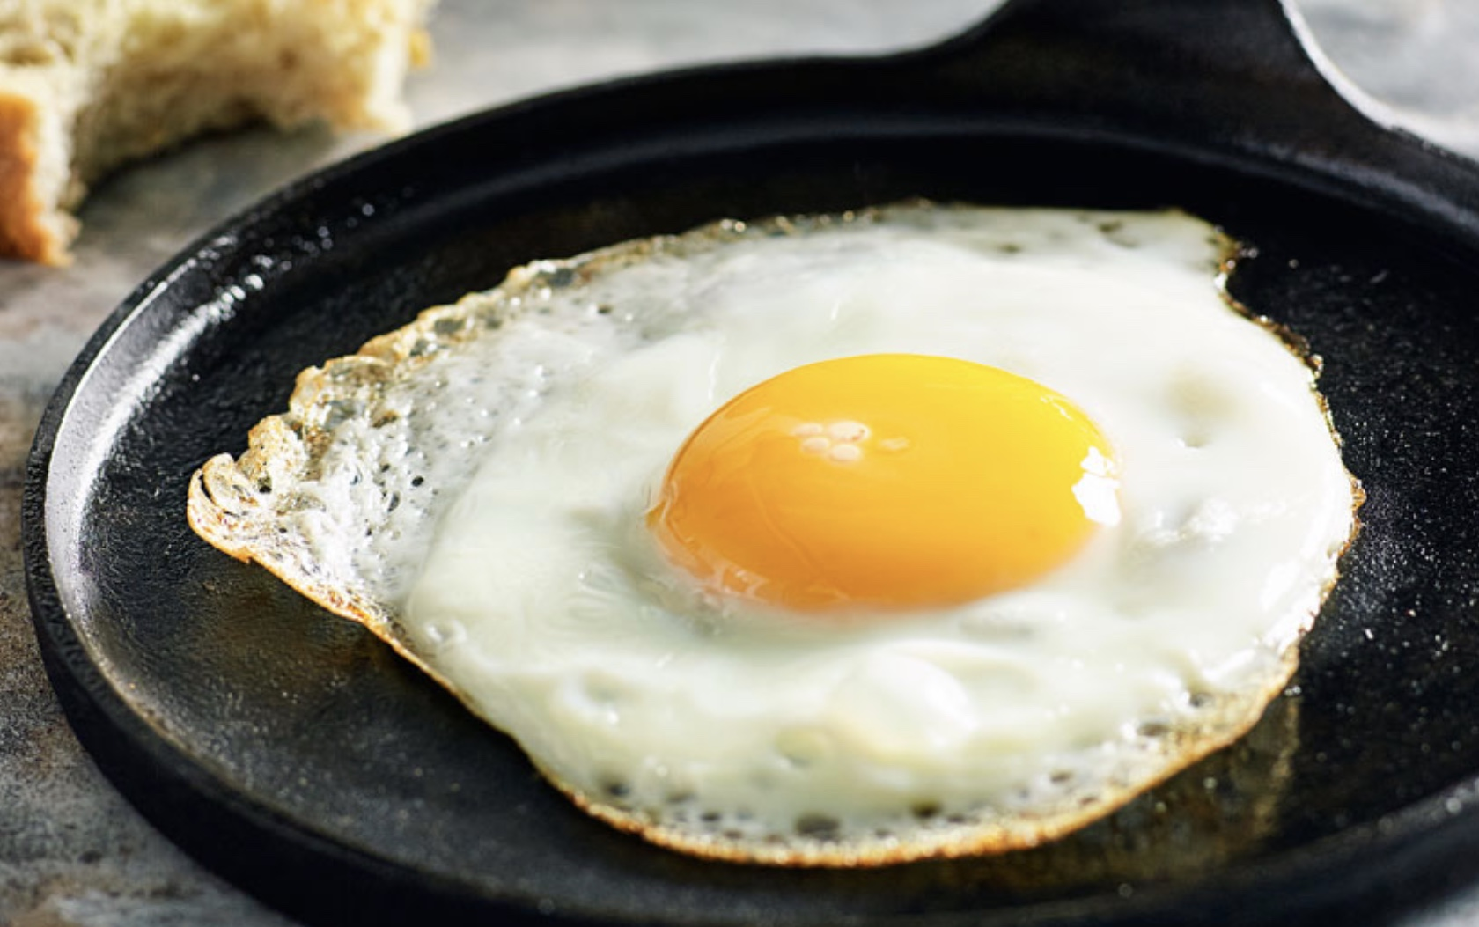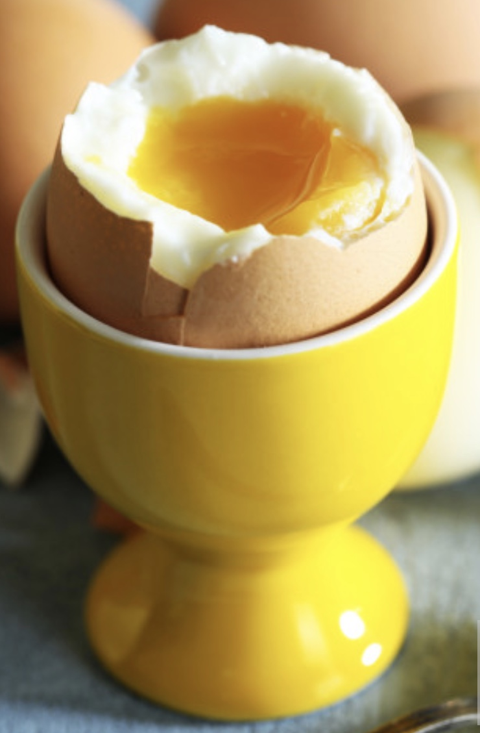Tally chart to show my family’s favourite way of eating an egg: