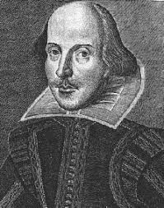
Shakespeare’s Will Q&A sheet

Take a look at these extracts from Shakespeare’s will, 1616:

- Write down what Shakespeare’s bequests were to the following people:
- Susannah (eldest daughter)

- Judith (second daughter)

- Joan Hart (sister)

- Joan’s three sons (nephews)

- Elizabeth Hall (granddaughter)

- the poor of Stratford

- Mr Thomas Combe (friend’s nephew)

- Who, in your opinion, is missing from the list above?

- Who is put in charge of the will (the executor)?

- What does Shakespeare leave to his wife?

- Is there anything to suggest even this bequest is an afterthought?

- Many experts suggest that this is in no way an insult – suggest three alternative explanations for Shakespeare’s gift

