These are extracts from Shackleton’s diary from the 5th Dec 1914 through to 24th February 1915. I have added the photos to help you visualise what happened. The black and white photos are the photos that the crew took at the time!
I will let him tell you the story:

I decided to leave South Georgia about December 5, and in the intervals of final preparation scanned again the plans for the voyage to winter quarters. What welcome was the Weddell Sea preparing for us?

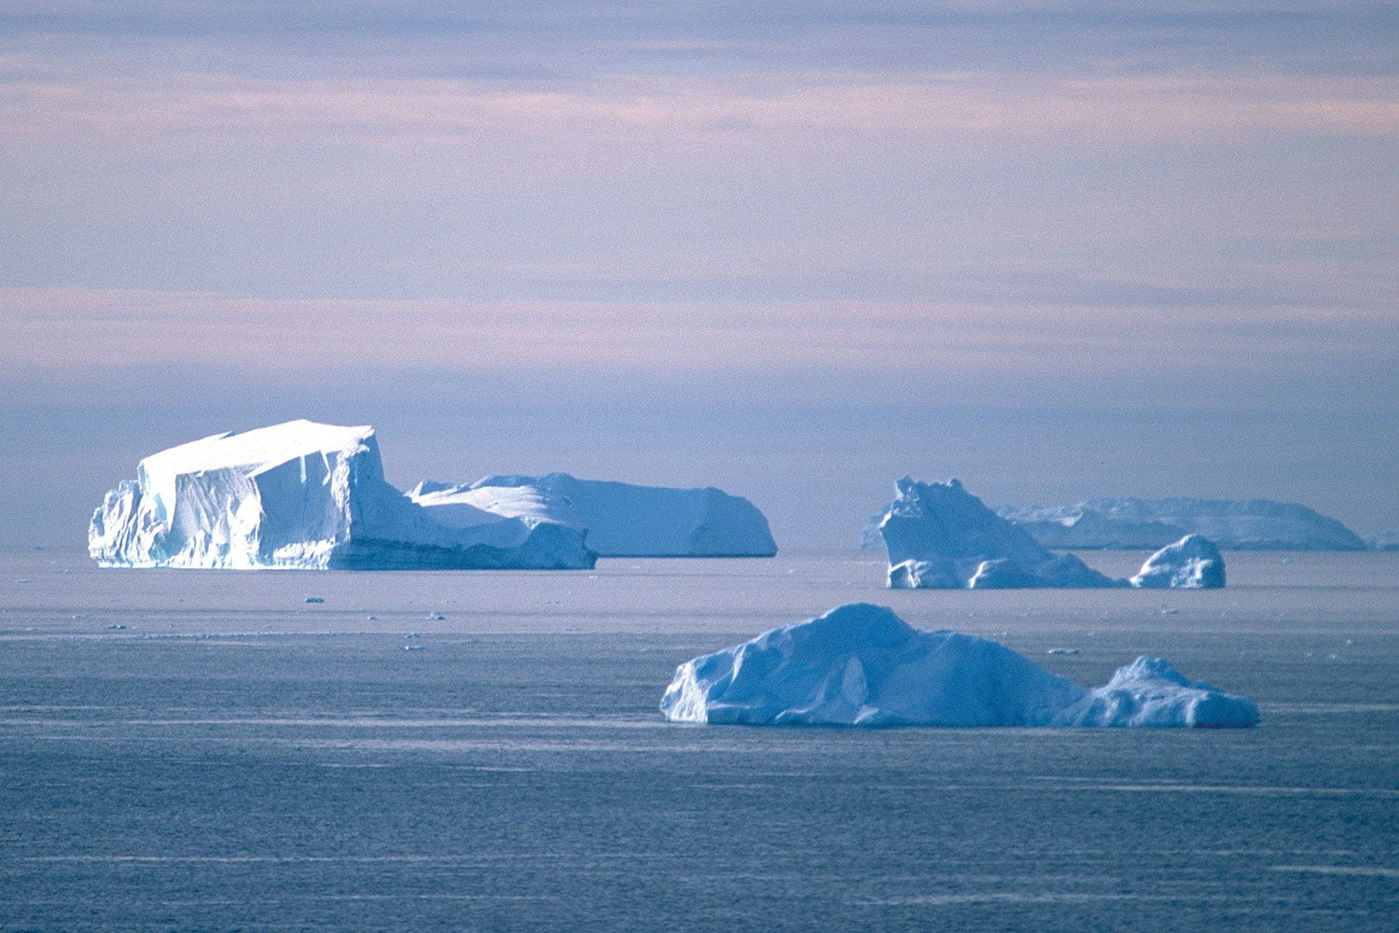

The day of departure arrived. I gave the order to heave anchor at 8.45 a.m. on December 5, 1914, and the clanking of the windlass broke for us the last link with civilization. The morning was dull and overcast, with occasional gusts of snow and sleet, but hearts were light aboard the Endurance. The long days of preparation were over and the adventure lay ahead.
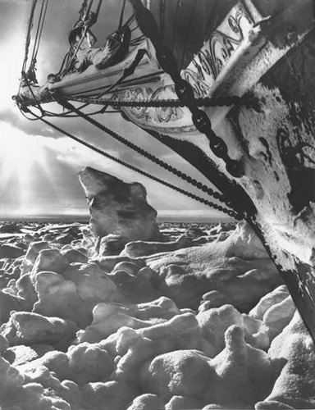

During December 6 the Endurance made good progress on a south-easterly course. The northerly breeze had freshened during the night and had brought up a high following sea. The weather was hazy, and we passed two bergs and numerous lumps of ice. Staff and crew were settling down to the routine. Bird life was plentiful, and we noticed Cape pigeons, whale-birds, terns, mollymauks, nellies, sooty, and wandering albatrosses in the neighbourhood of the ship.

The conditions became harder on December 14. There was a misty haze, and occasional falls of snow. A few bergs were in sight. The pack was denser than it had been on the previous days. Older ice was intermingled with the young ice, and our progress became slower. The propeller received several blows in the early morning, but no damage was done. A platform was rigged under the jib-boom in order that Hurley might secure some kinematograph pictures of the ship breaking through the ice.

The Endurance made some progress on the following day. Long leads of open water ran towards the south-west, and the ship smashed at full speed through occasional areas of young ice till brought up with a heavy thud against a section of older floe. Worsley was out on the jib-boom end for a few minutes while Wild was conning the ship, and he came back with a glowing account of a novel sensation. The boom was swinging high and low and from side to side, while the massive bows of the ship smashed through the ice, splitting it across, piling it mass on mass and then shouldering it aside. We continued to advance through fine long leads till 4 a.m. on December 17, when the ice became difficult again

The morning of December 18 found the Endurance proceeding amongst large floes with thin ice between them. The leads were few. There was a northerly breeze with occasional snow-flurries. Shortly before noon further progress was barred by heavy pack, and we put an ice-anchor on the floe and banked the fires. I had been prepared for evil conditions in the Weddell Sea, but had hoped that in December and January, at any rate, the pack would be loose, even if no open water was to be found. What we were actually encountering was fairly dense pack of a very obstinate character.

But, after battling for three hours with very heavy hummocked ice and making four miles to the south, we were brought up by huge blocks and floes of very old pack. Further effort seemed useless at that time, and I gave the order to bank fires after we had moored the Endurance to a solid floe. The weather was clear, and some enthusiastic football-players had a game on the floe until, about midnight, Worsley dropped through a hole in rotten ice while retrieving the ball. He had to be retrieved himself.

A crack about four miles long opened in the floe to the stern of the ship on the 3rd January. The narrow lane in front was still open, but the prevailing light breezes did not seem likely to produce any useful movement in the ice. Early on the morning of the 5th a north-easterly gale sprang up, bringing overcast skies and thick snow. Soon the pack was opening and closing without much loosening effect. At noon the ship gave a sudden start and heeled over three degrees. Immediately afterwards a crack ran from the bows to the lead ahead and another to the lead astern. I thought it might be possible to reeve the ship through one of these leads towards open water, but we could see no water through the thick snow; and before steam was raised, and while the view was still obscured, the pack closed again.

At the beginning of February, the pack seemed to be more solid than ever. It stretched almost unbroken to the horizon in every direction, and the situation was made worse by very low temperatures in succeeding days. The temperature was down to zero on the night of the 7th and was two degrees below zero on the 8th. This cold spell in midsummer was most unfortunate from our point of view, since it cemented the pack and tightened the grip of the ice upon the ship.

The second half of February produced no important change in our situation. Early in the morning of the 14th February I ordered a good head of steam on the engines and sent all hands on to the floe with ice-chisels, prickers, saws, and picks. We worked all day and throughout most of the next day in a strenuous effort to get the ship into the lead ahead. The men cut away the young ice before the bows and pulled it aside with great energy. After twenty-four hours' labour we had got the ship a third of the way to the lead. But about 400 yards of heavy ice, including old rafted pack, still separated the Endurance from the water, and reluctantly I had to admit that further effort was useless. Every opening we made froze up again quickly owing to the unseasonably low temperature.

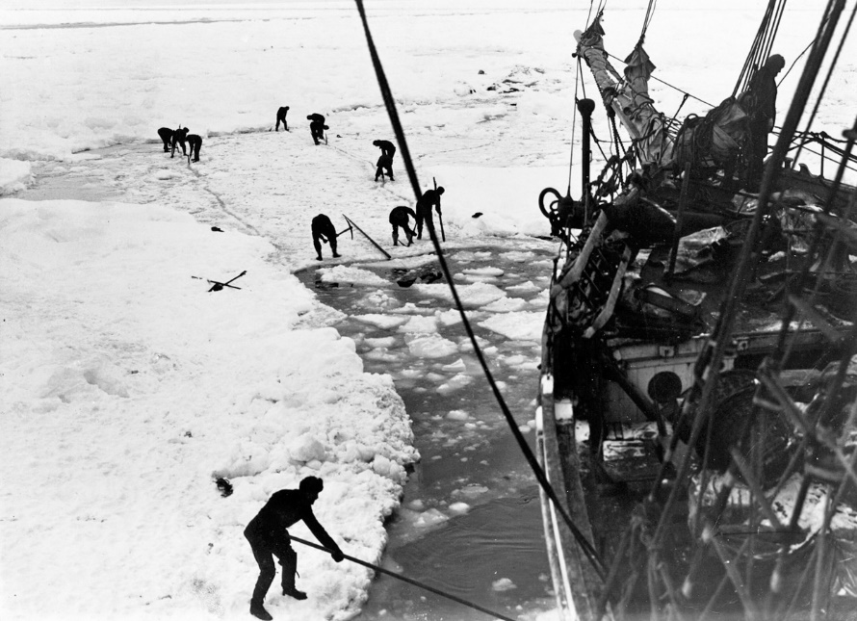

On February 24 we ceased to observe ship routine, and the Endurance became a winter station. All hands were on duty during the day and slept at night, except a watchman who looked after the dogs and watched for any sign of movement in the ice. We cleared a space of 10 ft. by 20 ft. round the rudder and propeller, sawing through ice 2 ft. thick, and lifting the blocks with a pair of tongs made by the carpenter. Seals appeared occasionally, and we killed all that came within our reach. They represented fuel as well as food for men and dogs. Orders were given for the after-hold to be cleared and the stores checked, so that we might know exactly how we stood for a siege by an Antarctic winter. The dogs went off the ship on the following day. Their kennels were placed on the floe along the length of a wire rope to which the leashes were fastened. The dogs seemed heartily glad to leave the ship, and yelped loudly and joyously as they were moved to their new quarters. We had begun the training of teams, and already there was keen rivalry between the drivers. The flat floes and frozen leads in the neighbourhood of the ship made excellent training grounds. Hockey and football on the floe were our chief recreations, and all hands joined in many a strenuous game. Worsley took a party to the floe on the 26th and started building a line of igloos and "dogloos" round the ship.
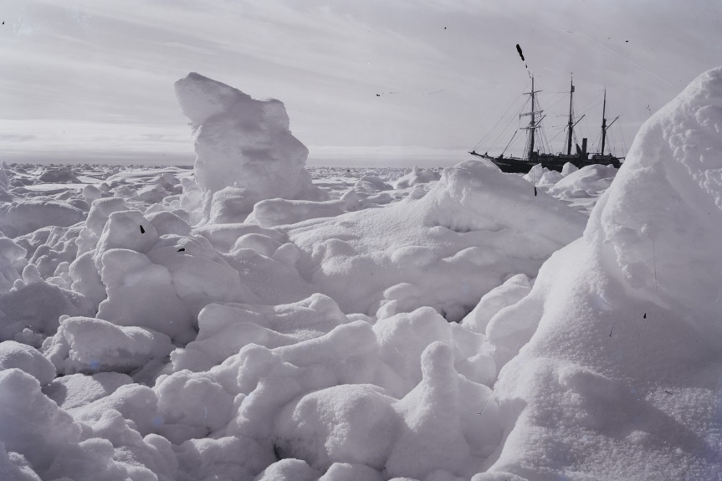
Activities:
Lesson 1 – can you draw up a timeline of the events from December 5th to February 24th.
Summarise what happened in this period.

Lesson 2 & 3 :
This is how far the Endurance got into the pack ice of the Weddell sea.
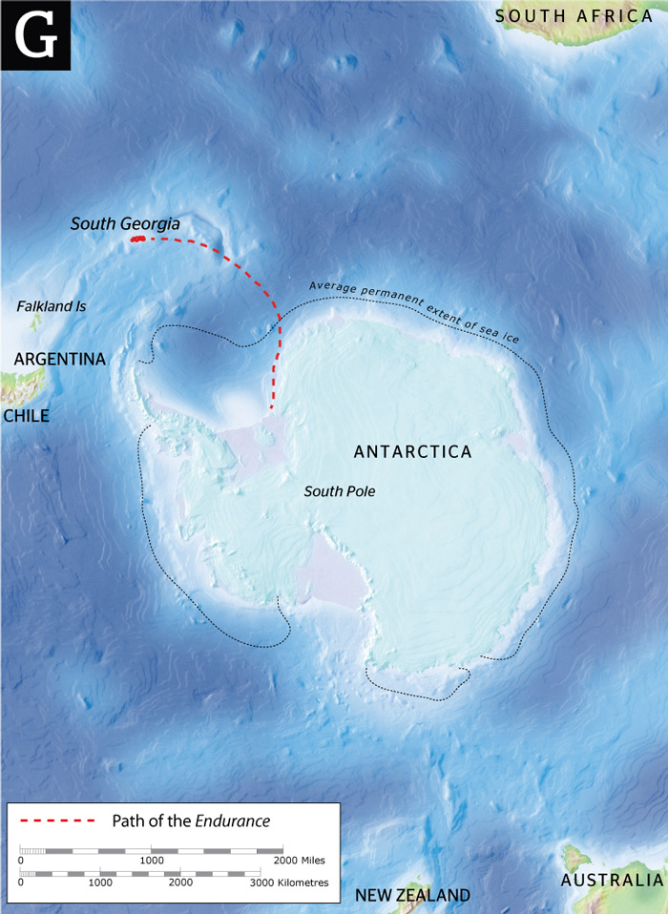

Can you compare it to the proposed plan of the trip that we looked at a few weeks ago.

The sailors played sports on the ice – can you list which sports they played.
Can you make up a game that they could play on the ice? Be creative. Write down the rules and equipment needed.

Lesson 4
Can you write the next part of his diary explaining what they did the next day when they woke up. Did they stay put and wait for the weather to improve? Or did they dig out the boat? What did they eat? Did they try to radio for help? Could anyone hear them?
What was the weather like? What could they see?
How was he feeling? How did he encourage his sailors?
Is he hopeful or despairing?

