Vincent van Gogh painted over 30 self-portraits between the years 1886 and 1889. His collection places him among the most prolific self-portraitists of all time. He used it as a method to make money, method of reflection and a method of developing his skills as an artist.

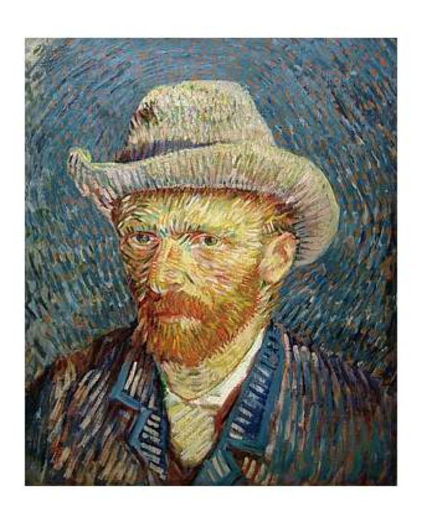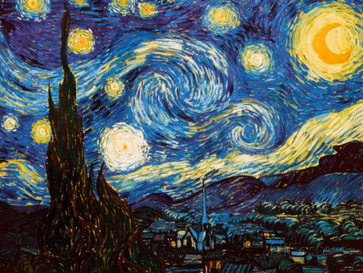[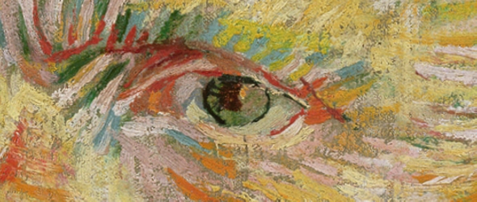](http://www.google.co.uk/url?sa=i&rct=j&q=&esrc=s&frm=1&source=images&cd=&cad=rja&uact=8&ved=0CAcQjRw&url=http://www.artistsandillustrators.co.uk/how-to/portraits-figurative/283/how-to-paint-van-goghs-self-portrait-technique-masterclass&ei=bMc-VYKIENLhaLqDgOAJ&bvm=bv.91665533,d.d2s&psig=AFQjCNGEz_0ymK-Fv2rAG80fc4wiZlA9hw&ust=1430264023491892)

**Task**

In the last task I asked you to draw a self-portrait using the correct proportions. Now I would like you to draw a new self-portrait in proportion (or if you can photocopy your original drawing) and try out the impasto inspired technique. In class we would use oil pastels but you can use paint, crayons or coloured pencils. Make sure you fill the whole page and don’t be scared about using a whole range of colours (look at the colours used in Van Goghs’ self-portrait). Remember to draw or paint each line of colour.

S.C.

1. Have I chosen colours close to my own complexion?

2. Have I chosen some colours that are in contrast and that reflect my personality?

3. Have I used small lines that follow the contours of my face?

4. Have I mixed the colours together by drawing the different lines next to each other on the page?

5. Have I created a background with either swirls or lines moving in the same direction?

Vincent Van Gogh used the impasto style technique in his paintings. Impasto is a painting term that refers to the use of thickly textured, undiluted, paint that appears almost three-dimensional on the canvas. When an artist uses the impasto technique they usually leave visible brush strokes on the finished painting. They apply the undiluted colour to the canvas, frequently with a palette knife, and mix colours on the canvas to attain the desired colour. When the painting is viewed from the side the paint is seen sticking out from the canvas in globs. Van Gogh is said to be a pioneer in using the impasto technique. Van Gogh used impasto not just to add dimension to his paintings but to add emotion and movement. We see this movement in the swirling clouds of Wheat Field with Cypresses and Starry Night. The same colors and images could have been created with a traditional painting technique but the movement and emotion of the painting would be missing.