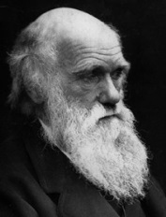 Notes on Charles Darwin
- Date and place of birth

Charles Darwin’s father, who was a doctor, and his mother lived in Shrewsbury, England. Charles was their fifth child, born on 12th February 1809.

- Early life
Charles loved exploring the countryside and he loved nature, but he hated school. His father just thought he was lazy so sent him to Edinburgh in Scotland to learn medicine to become a doctor.

Charles hated medicine so Charles quit and his father suggested a new career, to become a priest. Charles attended Christ’s College, Cambridge to study.

At Cambridge, Charles met two professors who were interested in plants and rocks. Both professors taught Charles how to study nature in a scientific way. Finally Charles found something he loved!
- Voyage on the Beagle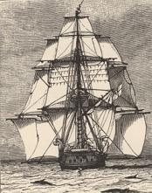
When Charles was 22 he was invited to join a voyage round the world as the ship’s naturalist (a type of biologist who studies species and the environment in which they live in). H.M.S. Beagle was a ship responsible for travelling the globe, making maps of coastlines. The Beagle was to go all the way across the Atlantic to South America to draw maps of the coastline. They returned home via the Galapagos Islands, New Zealand, Australia and South Africa. It took five years!
- Darwin’s theory of evolution
On the voyage Darwin spent a lot of time reading books. One book he read was by a man called Charles Lyell, who was an expert on rocks. Lyell had decided that the earth was very old, millions of years old, and that over time it had changed very slowly. He also said that we can see this happening today.

When the Beagle docked on land Charles set about testing Lyell’s idea. Everything he saw convinced Charles that Lyell was right, so he started thinking about life as being very old and possibly changing slowly over time.

In South America Charles found some amazing fossils. Fossils are the remains of very old animals and plants that have been buried and turned into rock. Charles found fossils of ten foot tall sloths, and huge cow-sized armadillos! These fossils convinced him further that life on earth was very old.

Galapagos Islands
When the Beagle stopped at the Galapagos Islands, in the Pacific Ocean, Darwin found some really strange animals. He found lizards that swam in the sea and tortoises big enough to be ridden like horses.

He collected lots of specimens and some of the specimens he collected were finches (a type of bird) from the Galapagos, he found 13 different species!
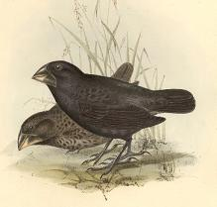
Island observations
Charles noticed similarities between fossils and living species within the same area. He saw that every island had its own kind of tortoises and birds that were all slightly different in appearance.

He developed the theory that all the different types of animals had started from a single species and had adapted to life on the different islands in different ways.
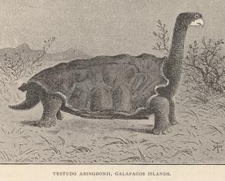
Darwin also started thinking about how animals and plants change through time, they could evolve and he thought he knew why. Charles saw that individual animals and plants compete with each other for food, water and space: the things they needed to live. They were fighting for their lives and only the fittest survived!

He also saw that individuals were different from each other but parents and offspring were more similar. Charles thought different individuals might survive better than others because they were a little bit bigger or better at something, and that if they did survive they would have more offspring. Over time all the little differences would add up until you saw a big difference. Darwin called this process natural selection.
An example
Darwin studied different finches living in different parts of the Galapagos Islands and realised, even though they were different, they all had the same ancestors! Some had evolved to have larger beaks in certain areas, some with smaller beaks in other areas due to different food being available.
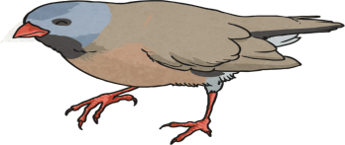
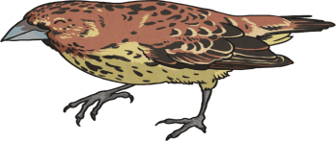
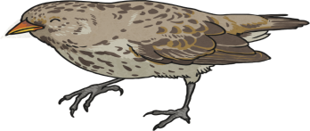

For example the ones with large beaks that eat hard nuts reproduced and had offspring. More of these offspring inherited large beaks and survived. Those offspring with smaller beaks died off. In other parts of the Galapagos, smaller beaks ensured better survival than larger ones because of their particular food source. The adaptations meant that over a long period of time, the Galapagos finches evolved adaptive traits that caused differences between them.
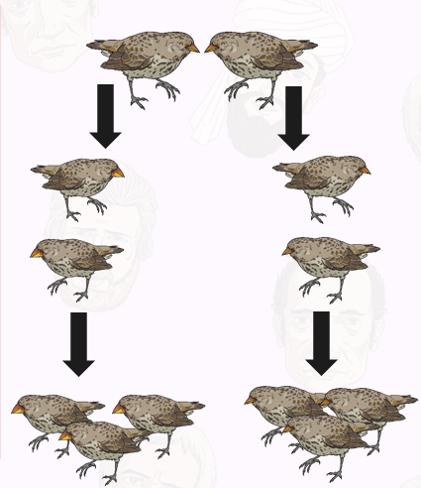
Reactions to Darwin’s theory when it was published
In 1859 he finally wrote a book about what he had found out: On the Origin of Species. It was a sensation! Some people were very angry because they believed that a higher being had created all animals and plants and that they had stayed the same. Charles’ idea also meant that humans evolved too just like any other animal and he concluded that humans evolved from apes.
Darwin had so much evidence that scientists decided he was right. Charles became very famous and got lots of awards and prizes.
When Charles died, in 1882, aged 72 the country decided he was such an important scientist he should be buried in Westminster Abbey. This was a privilege of only the very most important people.

