Wednesday 24th June 2020
L.O: To identify and name a variety of common animals including fish, amphibians, reptiles, birds and mammals.

Giraffe Group:
Draw a picture of 3 animals from 3 of the chosen animal groups and label, use the PowerPoint to help you.

Wednesday 24th June 2020
L.O: To identify and name a variety of common animals including fish, amphibians, reptiles, birds and mammals.
Elephant and Lion Group:
Draw an animal from each animal group and label with the group they are from. Can you remember any facts from the animal groups?

Wednesday 24th June 2020
L.O: To identify and name a variety of common animals including fish, amphibians, reptiles, birds and mammals.
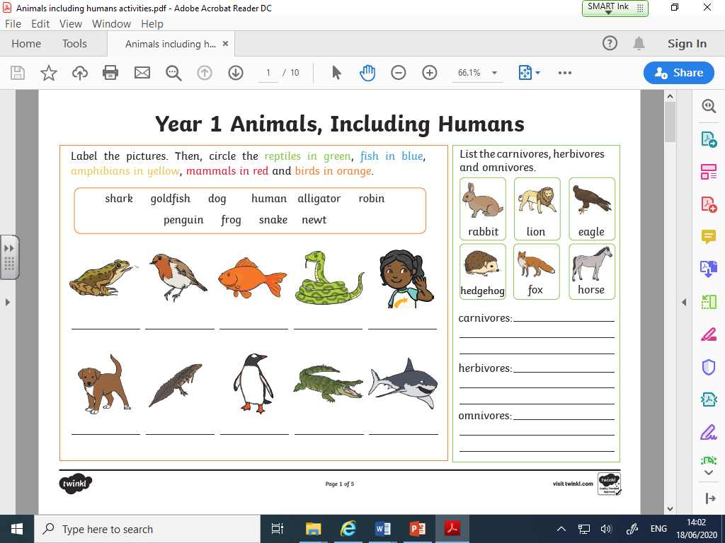
Cheetah and Meerkat Group:

