Rectangles Work – Subtraction Fluency Questions
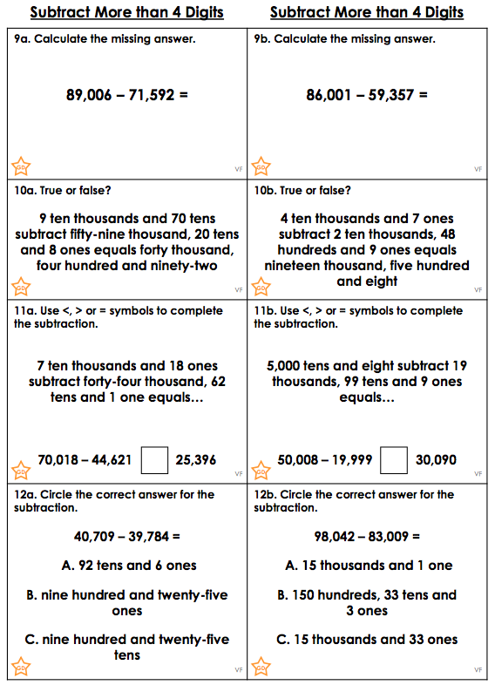

Rectangles Work – Problem Solving Questions
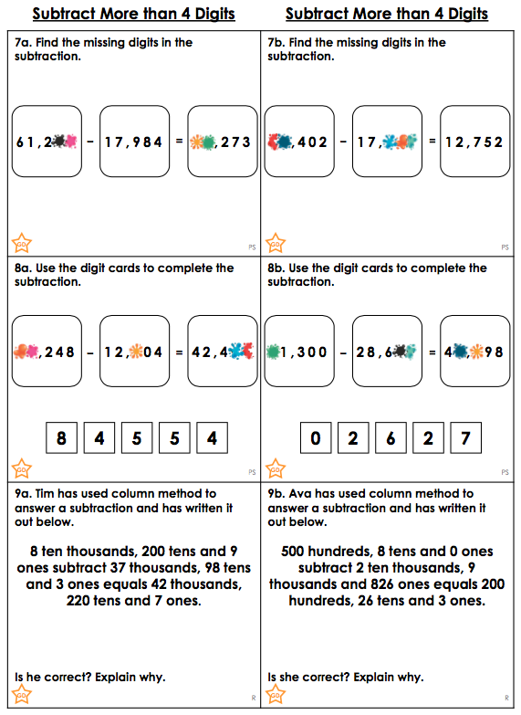

Rectangles Work – Answers

Fluency

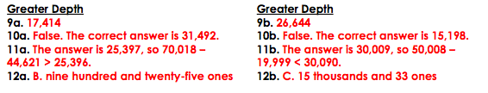

Problem Solving
