Rectangles Work – Addition Fluency Questions
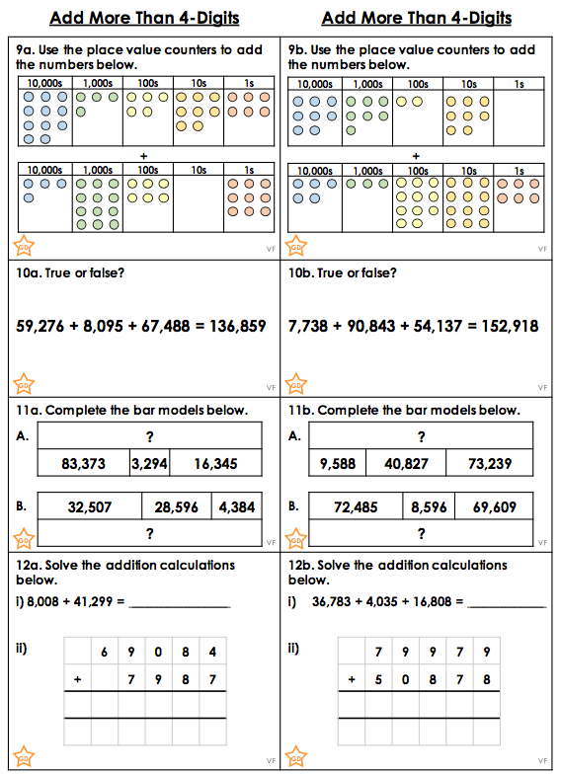

Rectangles Work – Problem Solving Questions
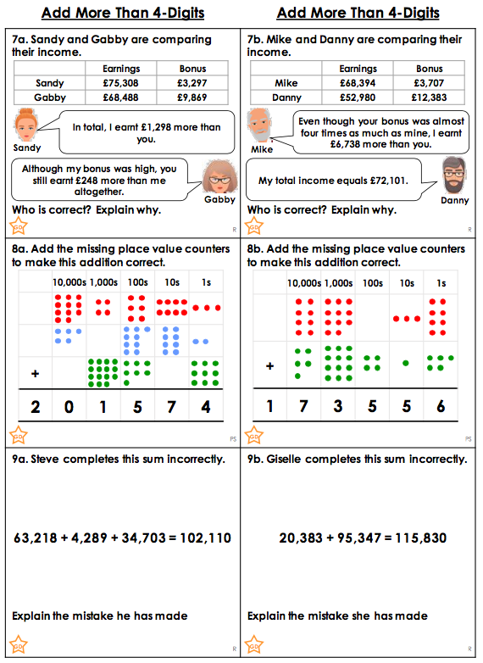

Rectangles Work – Answers

Fluency

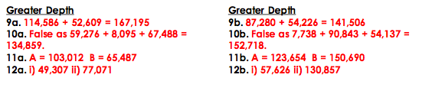

Problem Solving

