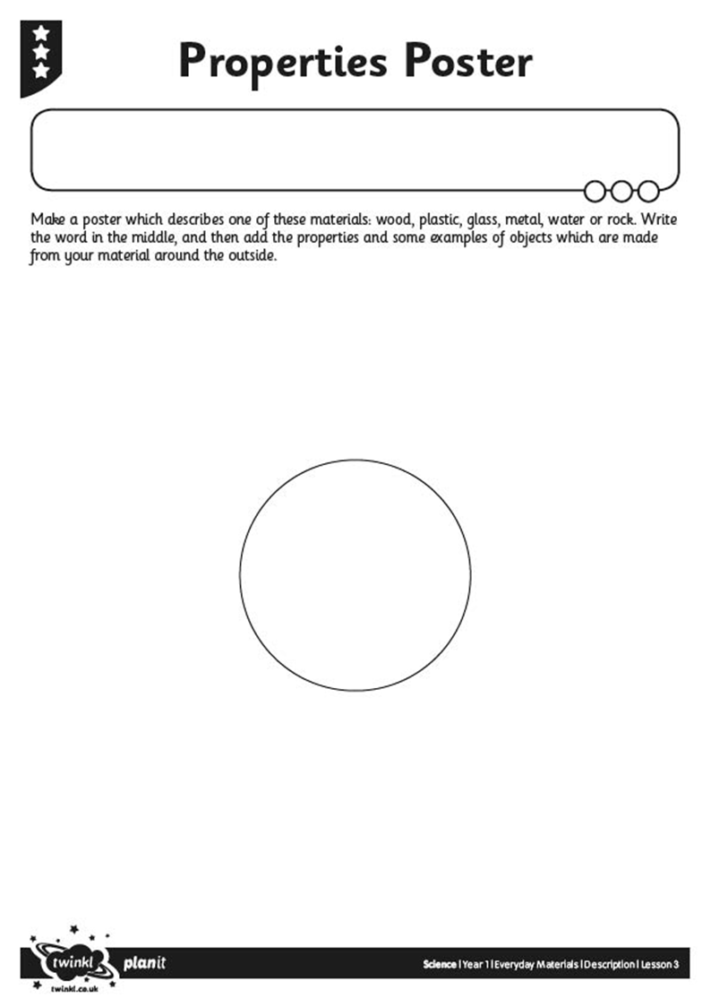

**Properties Poster**

**You can draw the objects and colour them in too.**