March, 2020
Presentation
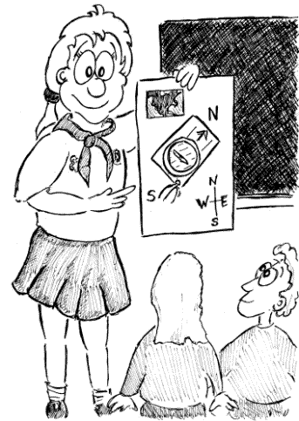
I have a little project for the children to complete. I would like everyone to give a short talk to the rest of the class, in the first week or two after the Easter holiday (assuming we are back in school), about something that they like, do or are just interested in.
Their project is to prepare for this talk. They will only have to speak for around 2 or 3 minutes. Their talk could be on one of their hobbies/sports, or a favourite book or film, on their love of computers/consoles/a particular game or on something that really interests them.
It's up to them what subject they choose (In the past we’ve had talks about; Owls, Star Wars, Horse Riding, Science, Magic etc), but they need to think carefully about what they're going to say. They could write a few notes on a piece of paper to help them or plan and write out a full script. It's a good idea to write the order that you're going to talk about things as well. They need to try and give enough detail to make it interesting, yet keep it simple enough that they don’t get muddled.
Visual aids will make their talk more interesting. Visual aids are things like pictures, posters, objects or props (bringing in the object or item is ok, so long as it is not too big). They can even write on the class board if they wish (or email in simple/small PowerPoints to the school office – for my attention).
This is not an easy task, but will challenge the children’s speaking and listening, confidence and presentation skills (and is great evidence for me!). They need to think of it as just a more detailed, planned version of SHOW and TELL, which they’ve all done before. As a task for them to do whilst off, this is one that they can dip in and out of.
Unlike the other activities within the School Closure pack, this one is a Homework task and therefore needs to be done. Every child will present to the class.
Kind regards,
Mr Bass

