In Maths the learning objective is ‘to know what each figure in a two digit number represents.’

It is really important that your child knows the value of numbers and how they are put together. The video clips will help to explain this.

- Ask your child how many ones (or units) there are in 9. Perhaps they could count 9 objects out or something else that is small. Dried pasta is good to use, if you can get it!
- Ask how many tens there are in 23? Again, use pasta to count out 2 groups of ten and then 3 ones.
- How many ones are there in 34?
- Which number is bigger 5 tens and 3 ones or 3 tens and 5 ones?

We have created the following activities for your child to complete. Please remind them to complete the sheet that has their coloured Maths group at the top. However, if they feel like a challenge, then please do have a go at the other sheets.

LO: to know what each figure in a two digit number represents

Red Group
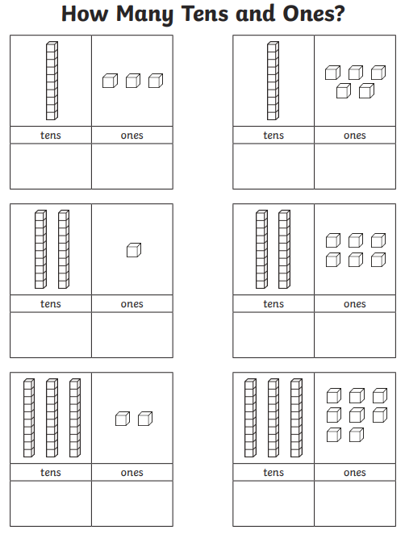

LO: to know what each figure in a two digit number represents

Yellow Group
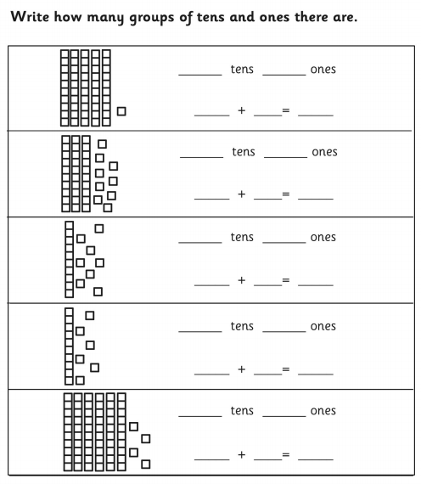

LO: to know what each figure in a two digit number represents

Green Group
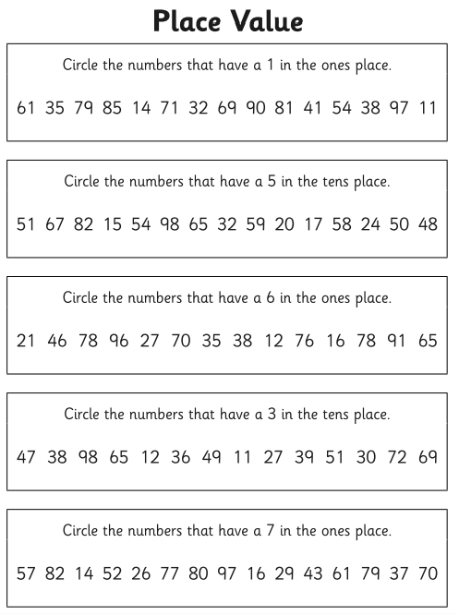

LO: to know what each figure in a two digit number represents

Orange and Blue Group
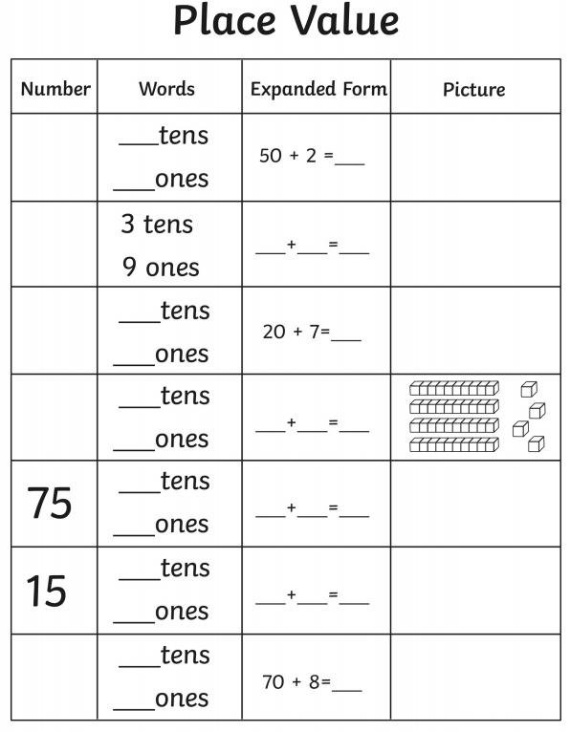

Extension:
LO: to know what each figure in a two and three digit number represents
