PE - Fitness
Session 3:
Warm-up
Play Simon Says:
Ideas to try – 3 point balance, 2 point balance, jumping air squat, v-sit, touch toes, jump as high as possible, spring on the spot, high knees, freeze.

Strength work
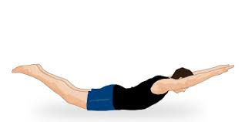
Time each position for 20 – 25 seconds before moving onto the next. Add a rest between the 3 rounds e.g. 20 or 30 seconds.
1. Plank
2. Arch hold
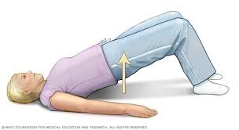
3. Bridge
4. Tiptoe balance
Repeat three times.

AMRAP (As Many Reps As Possible) 15:
You should record how many rounds and reps you completed in the 15-minute time limit.
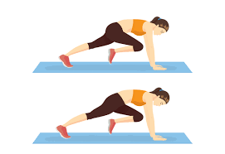
- 5 sit ups
- 5 burpees (see diagram from last week)
- 5 star jumps
- 5 mountain climbers (see diagram right)
When you have finished one round you should start again and keep going through the exercises for 15 minutes.
Cool down
- Lie on your back.
- Leave the left leg on the floor extended or slightly bent.
- Draw the right knee towards the chest and lace fingers over shin to hold leg.
- Allow shoulders to relax.
- Take 8 to 10 breaths in through the nose out and out through the mouth.
- Swap legs and repeat 2 or 3 times

Session 4:
Warm-up
Play Simon Says:
Ideas to try – 3 point balance, 2 point balance, jumping air squat, v-sit, touch toes, jump as high as possible, spring on the spot, high knees, freeze.

8-minute Exercise Ladder
A ladder refers to an increasing number of reps throughout a workout. In this instance, it is 3, 6, 9, 12 and so on. What rung of the ladder can you reach in 8 minutes? Have a short break between each set.
Start with:
- 3x lunge walks
- 3x Burpees
- 3x Star jumps
- 3x air squats (see below – add a jump to increase the difficulty!)
- 3x push ups (can be a full push up, from knees, or against a wall)
Then move to 6 reps, 9 reps, 12 reps etc.
What rung of the ladder can you reach in 8 minutes?
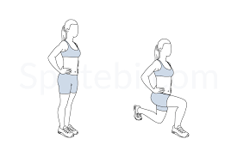
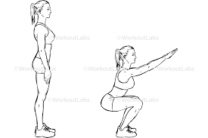

Cool-down
- Climb the ladder – Pretend to climb a ladder stretching arms and knees, slowly working up the ladder – perform for 15 – 20 seconds then move to…
- Butterfly Wings – Sit on the floor with soles of your feet touching, you should gently move your knees up and down like beating wings – perform for 15-20 seconds then move to …..
- Tunnel Toes – Stand feet shoulder-width apart you should reach down left hand to right foot and hold for 15 seconds, switch sides, then move back to climb the ladder repeat 2 or 3 times until you are calm and cool.
Well done!

