PE - Fitness
Session 1:
Warm-up
- March on the spot for 1 minute – high knees
- Jog on the spot for 1 minute
- Lie down on your back, get up and jump x4
- Lie down on your tummy, get up and jump x4
- Stretch up to the sky and take a deep breath x4

Tabata
Tabata is the name for a type of workout which is four-minutes long consisting of 8 rounds of 20 seconds of work at maximum effort, followed by 10 seconds of rest.
Tabata round 1:
- 20 seconds of jogging with high knees
- 10 seconds rest
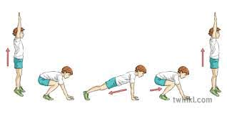
- Complete this 8 times
- Rest for 2–3 minutes
Tabata round 2:
- 20 seconds of burpees (see diagram)
- 10 seconds rest
- Complete this 8 times
- Rest for 2-3 minutes

Cool down
- March on spot for 16 – 32 beats allowing heart rate to drop.
- Lie down on back, arms and legs relaxed at side. Close eyes. Breath in through the nose and out through the mouth at own pace 5 times.
- Tense all muscles in the body, hold for 10 seconds, release.

Session 2:
Warm-up
1. Jumping on the spot x 16 beats
2. Jog in a circle to the left x 8
3. Jog in a circle to the right x 8 beats
4. Windmill arms forward x 10
5. Windmill arms backwards x 10
6. Stretch up to the sky and take a deep breath x 4

EMOM
An EMOM stands for Every Minute On the Minute.
In this exercise, you will complete one exercise for 1 minute then change to the next. This is a 20-minute EMOM.

- Minute 1 = Push Ups
- Minute 2 = Jumping Squats
- Minute 3 = Plank (see diagram below - remember to try to keep your body in a straight line!)
- Minute 4 = Skipping (with rope if available and able)
- Minute 5 = Rest and have a drink of water!

Repeat the above 5 minute activities four times to complete the 20-minute workout.

Easier: Push ups on knees. Standard squats. Plank against wall

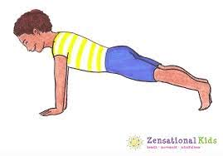

Cool-down
- March on spot for 16 – 32 beats allowing heart rate to drop.
- Lie down on back, arms and legs relaxed at side. Close eyes. Breath in through the nose and out through the mouth at own pace 5 times.
- Tense all muscles in the body, hold for 10 seconds, release.

Well done!

