Wednesday 10th June
LO: To order numbers to 100
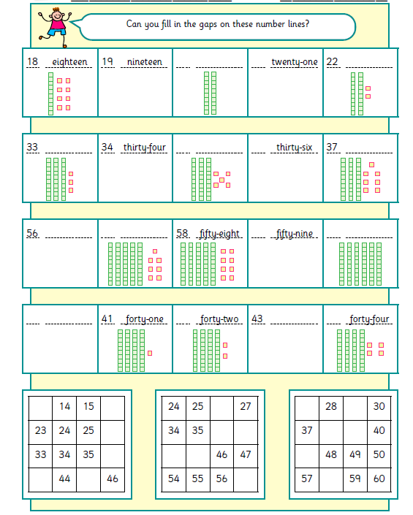
Use the numbers in words above to help spell the missing numbers correctly. The numbers below will also help you.
Two three four five six seven sixty
e)
d)
c)
b)
a)

