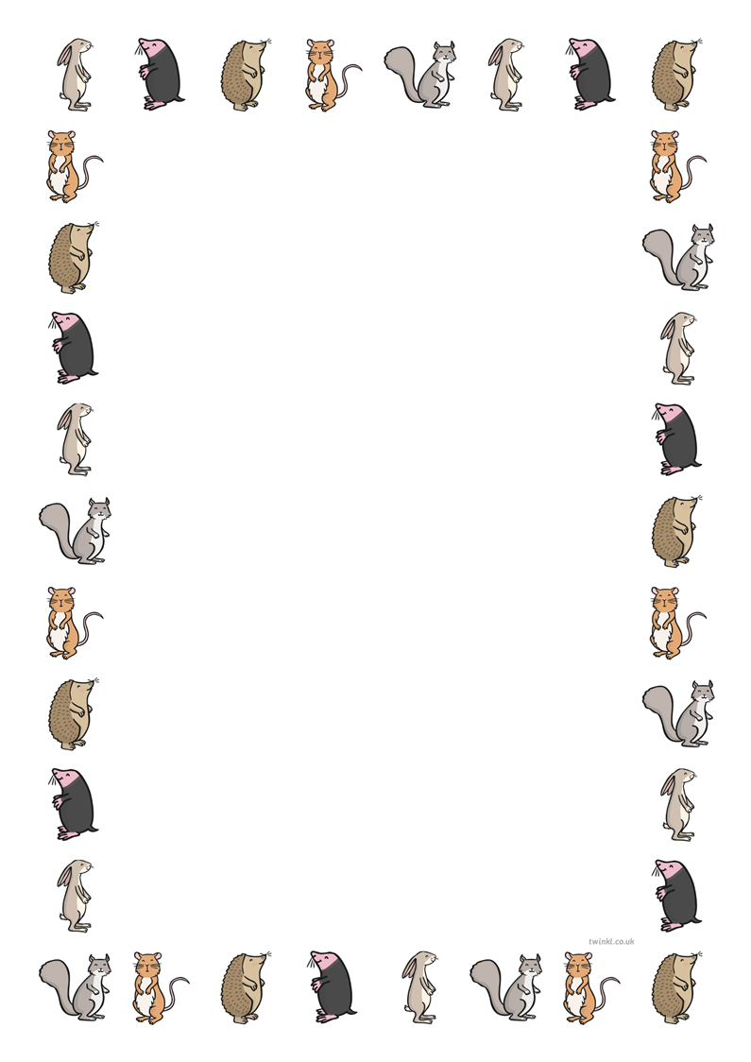

**Can you write 3 different titles for the story ‘One Snowy Night’?**

**Challenge:**

1. **Explain why you chose the 3 titles**
2. **Draw a new front cover for one of your new titles**