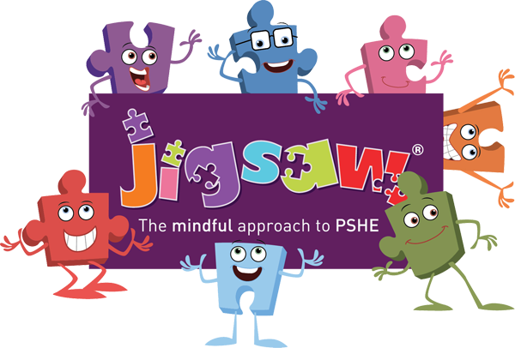
My ‘Family’ Recipe

In my ‘Family’ cake I need;

- 150g of happiness.

- 2 cupfuls of kindness.

- 4 teaspoons of hugs.

- 200ml of laughter

- 3 pieces of sharing.

- 75g of love.

