**Wc 30.03.20**

**L.O To recognise all coins, know their value, use them to make amounts, and recognise £5, £10, and £20 notes (Purple/Blue).**

**S.C 1. 2. 3.**

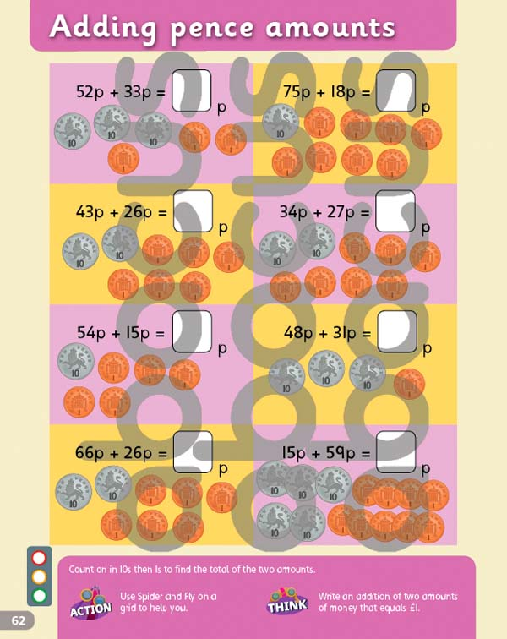

**Wc 30.03.20**

**L.O To recognise all coins, know their value, use them to make amounts, and recognise £5, £10, and £20 notes (Orange).**

**S.C 1. 2. 3.**

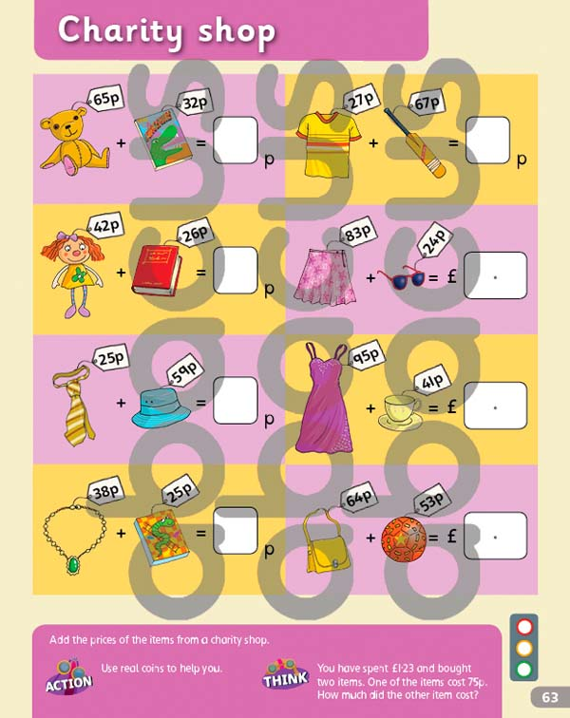

**Wc 30.03.20**

**L.O To be able to solve money problems (Green).**

**S.C 1. 2. 3.**

|  |  |  |  |  |
| --- | --- | --- | --- | --- |
| Pear  5p | Orange  7p | Apple  4p | Lemon  10p | Melon  12p |

Find the cost of…

1. one melon and one pear
2. one orange and one apple
3. one lemon and one orange
4. one apple and one lemon
5. one apple and one pear
6. two lemons
7. one apple and one melon
8. one apple, one pear and one lemon