Mehndi Hands
Revision - Last week I asked you to sketch some Indian patterns and to make some observations about the colours found in the designs. I hope that you noticed that some of the patterns were very detailed and intricate and that they were influenced by nature particularly plants or flowers. The patterns that were produced on the fabric were repeated, they tessellated and were often symmetrical. The designs were also bright and displayed vibrant colours including primary colours such as red, yellow and blue and secondary colours such as green and orange. Gold was also a popular colour.
Cultural Colours - Colour is an expression of faith and belief. In a country as diverse and culturally vibrant as India, colour holds together lifestyles and traditions. There is a huge diversity of population and so there are a range of representations of symbols and colour. Certain colours that have a special place in a particular area may not have the same statues elsewhere.
- Black often has connotations of evil, negativity absence of energy and death.
- White is the absence of colour and is the only colour widows are allowed to wear, it is an acceptable colour at funerals to mark the death in the family. White repels all light and colours so a widow disconnects herself of pleasures.
- Red can stand for purity, happiness, love, power and is the preferred colour for a brides garment, red has a deep meaning. Red also symbolises fertility and prosperity.
- The colour blue is associated with Lord Krishna perhaps one of the most favoured gods in India.
- Gold is considered as a sign of power and wealth and it also symbolises good health.
Mehndi Patterns
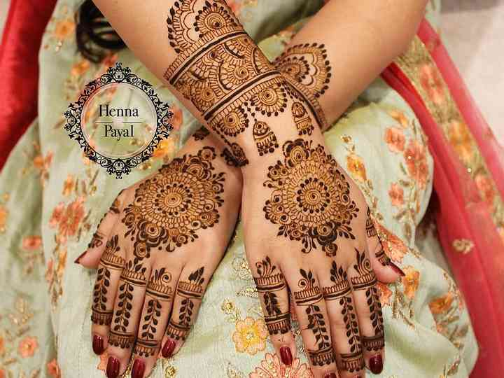
In the information I gave you last week the first sheet displayed examples of Mehndi patterns. Mehndi is the traditional art of painting hands, feet or body with a paste made from the powdered, dried leaves of the henna plant. It stains the skin a cherry-red to brown colour and can last up to three weeks. Mehndi patterns are used for special occasions, celebrations, weddings and engagements. They originated from long ago in India, when bridal decorations were scarce.
LO: To design a Mehndi pattern.
Task
This week I would like you to develop some design ideas for a Mehndi hand. First I would like you to draw around your hand at least twice onto a blank piece of paper (make sure you include the L.O. and date at the top of the page) or you can print off the Mehndi hand template worksheet. Then using your sketches from last week I would like you to create at least two different Mehndi hand designs. Each design needs to be intricate and detailed, you can draw using a pencil or a fine tipped black pen, if you have one available. The black pen works well at emphasising the patterns. Then using your understanding of popular colours found in Indian designs, I would like you to carefully shade in your design with coloured pencils. You can also highlight parts of your line design using gel pens to create a metallic look. Remember these are design ideas and they are not your finished artwork so it doesn’t matter if you make a mistake or if you prefer parts of each design because you can combine them together next week in your final piece. I have provided you with a Mehndi Henna Photo-PowerPoint resource if you are stuck for ideas (optional printing).
SC:
1. Have I used the resources and my sketch work to help develop ideas for my patterns?
2. Have I created intricate designs that cover the whole hand?
3. Have I drawn the design in pencil and/or pen?
4. Have I added colour to the design by using coloured pencils and have I used gel pens to highlight lines?

