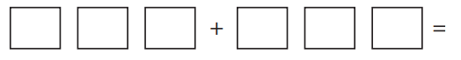
Throw a 1 to 6 dice and each time record a digit in one of the place holders above. The aim is to get the sum as low as possible. Repeat to find different answers.
Could you have done it a different way?
Compete against a family member and compare your answers.

