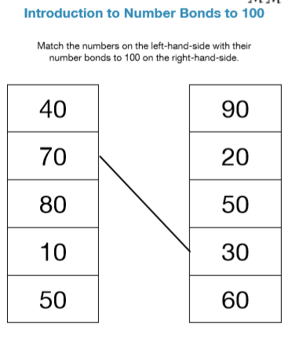

Can you write the related subtraction facts for each number pair?

E.g. If 40 + 60 = 100 then 100 – 40 = 60 and

100 – 60 = 40.