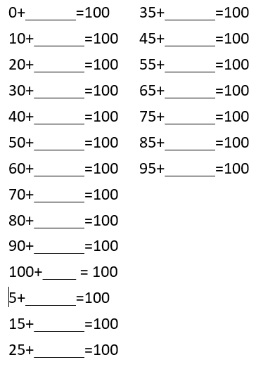

Can you write the related subtraction facts for each number pair?

E.g. If 15 + 85 = 100 then 100 – 85 = 15 and

100 – 15 = 85.