Mobile differences

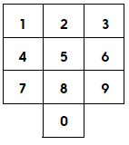
- Using this mobile phone digit display, create two 5-digit numbers using these two rules:
- The digits you choose must touch along a side. So you can choose 65214 because each digit touches the next one along a side.
- You may not use any digit other than 5 more than once. So if 98547 is your first number, then 65214 cannot be your second number as 4 is used twice. (NB. 5 may be used twice, even within the same number, e.g. 52145).
- Find the difference between your two numbers.

- Repeat, choosing two different numbers.

- Find the largest possible difference that you can make, using two 5-digit numbers generated according to the above rules.
Can you demonstrate that this is the largest possible difference?
- Find the smallest possible difference. (This is much harder!)

Challenge
Demonstrate that your smallest difference is indeed the smallest.
Find the difference nearest to 44,444.

