**14.1.2021**

**L.O:To solve addition problems**

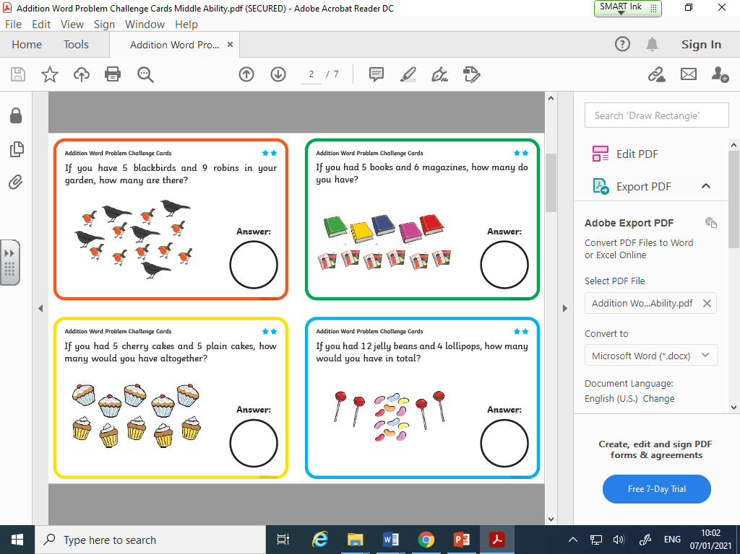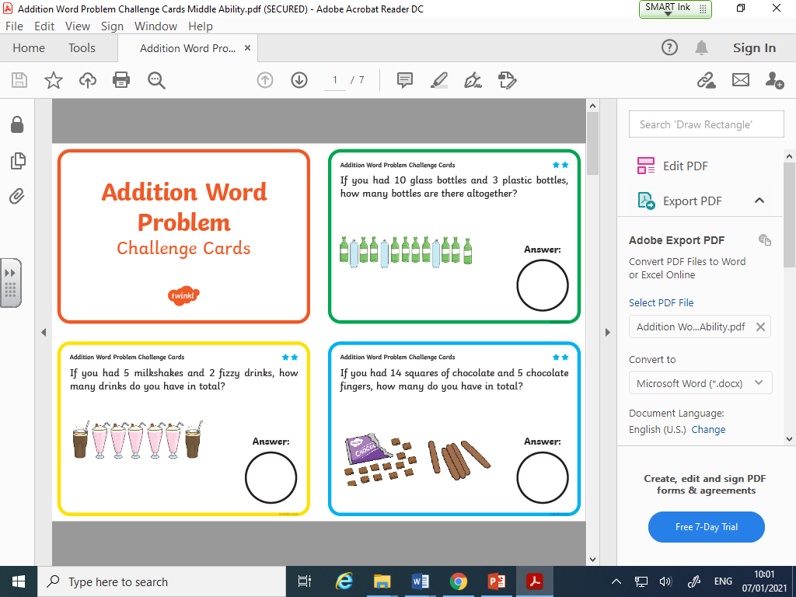**Rabbit and Owl group:**