Maths Lesson 3: Multiplying decimals by 10, 100 and 1000.
Independent Activities

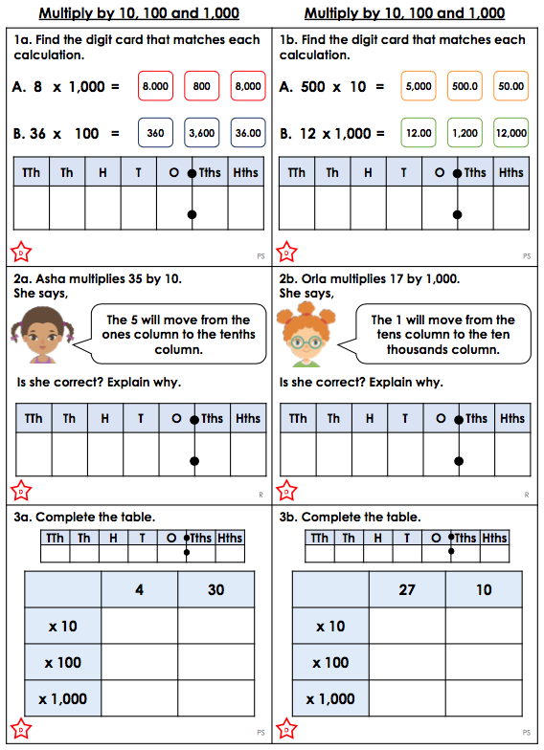

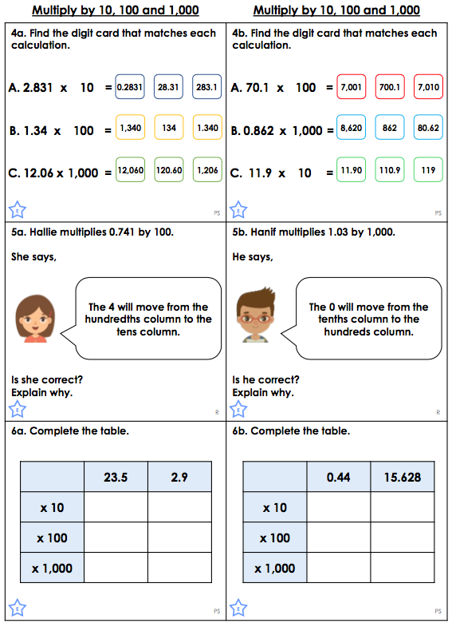

Extension Work: (Triangles and Rectangles)
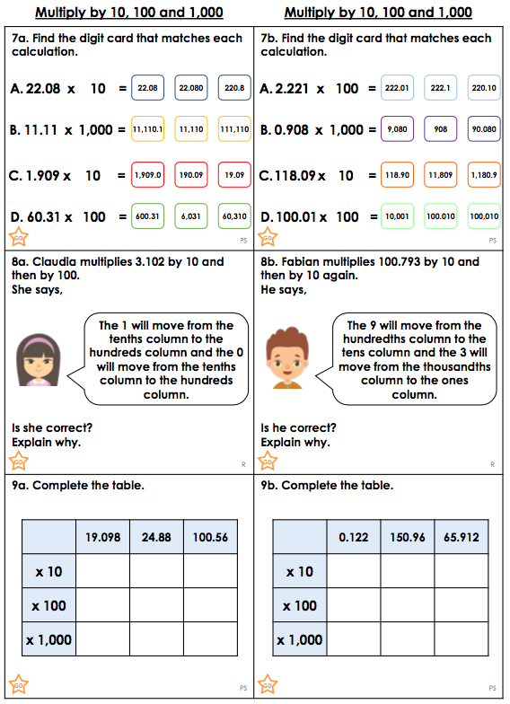

Further Extension Work
