Maths Lesson 3: Multiplying decimals by 10, 100 and 1000.
Independent Activities Extension Work:
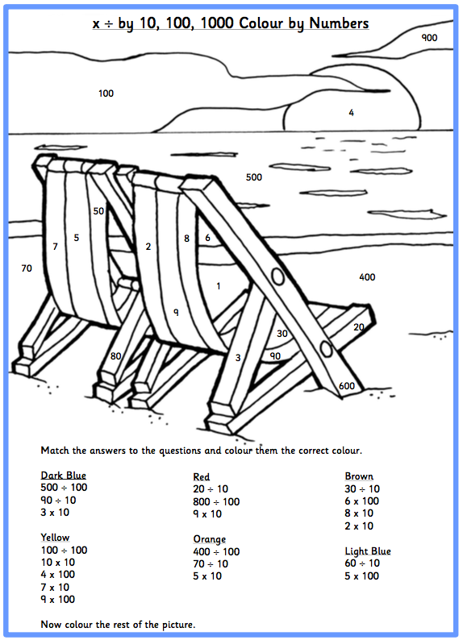

Answers
