Date
LO: To read Roman Numerals upto 100

Use the teaching PowerPoint from yesterday’s lesson to help you with these activities

Yellow and Blue tables;

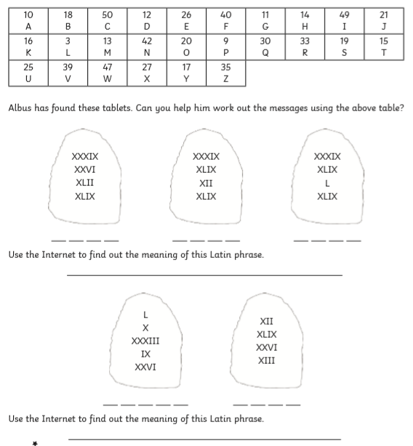

Green Table:

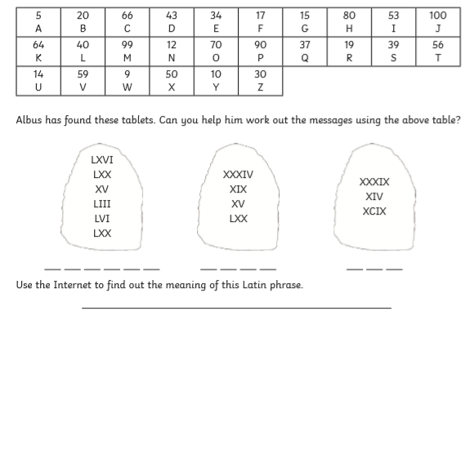

Red Table:

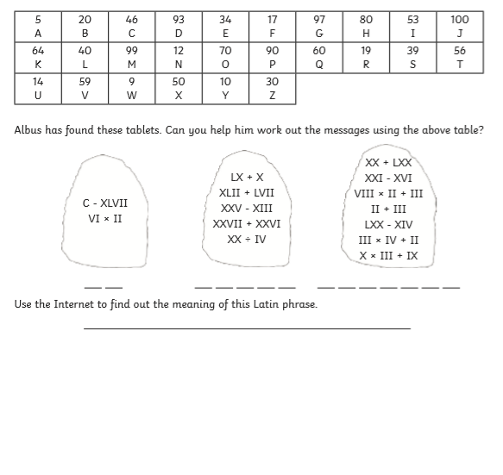

Good luck x

