**Day 3: LO: To recognise, find and name a quarter as one of four equal parts of an object or shape**

**Day 3: LO: To recognise, find and name a half as one of two equal parts of an object or shape**

**Foxes**

Follow the instructions the knights give you and create their designs.

**Beware** of Sir Decimal! You know he likes to cause trouble!

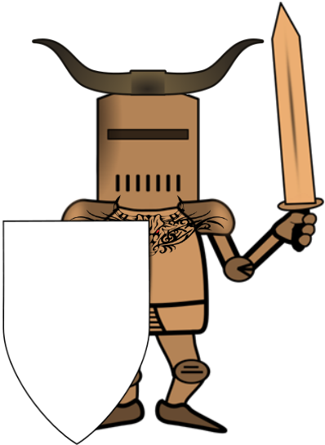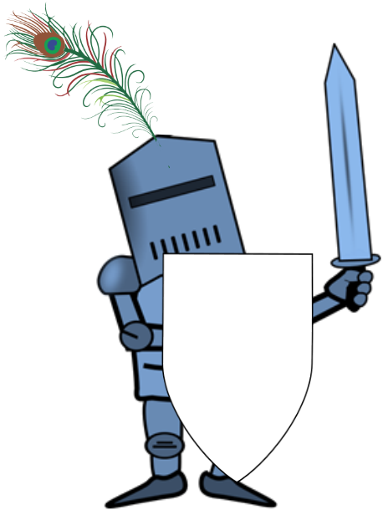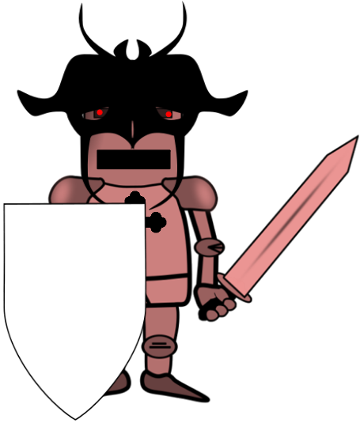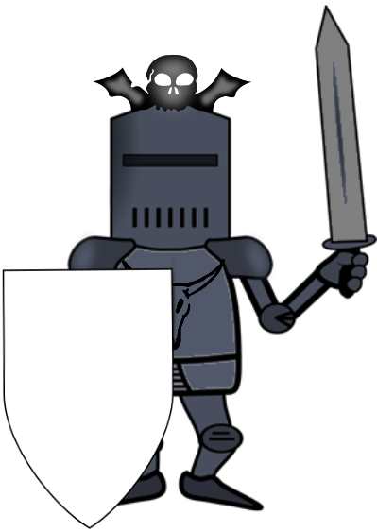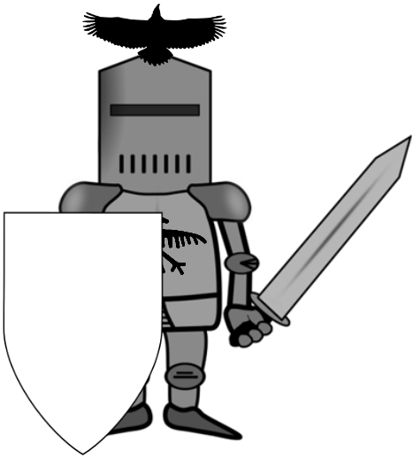

Shade in **one** **quarter** of this shape!

Shade in **one** **half** of this shape!

Shade in **one** **quarter** of this shape!

Shade in **one** **quarter** of this shape!

Shade in **one** **half** of this shape!

**Challenge:**

What do you notice about the last shield? What are two quarters the same as? _____________________________

Shade in **two** **quarters** of this shape!

Shade in **three** **quarters** of this shape!



Shade in **one** **half** of this shape!

Shade in **one** **quarter** of this shape!

Shade in **three** **quarters** of this shape!



Shade in **one** **quarter** of this shape!

Shade in **half** of this shape!

Shade in **one** **quarter** of this shape!

Shade in **half** of this shape!

Shade in **one** **quarter** of this shape!