Day 2: L.O: To add by putting the larger number first and counting on (numbers up to 30 and beyond)
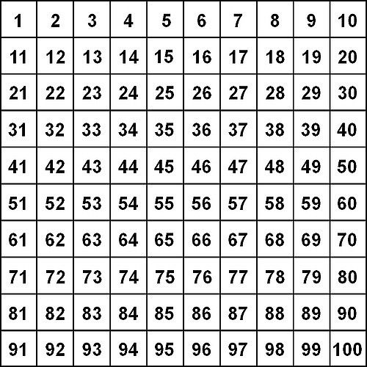

14 + 5 = 22 + 6 = 26 + 4 =

11 + 6 = 23 + 5 = 25 + 5 =

24 + 5 = 16 + 6 = 17 + 4 =

22 + 4 = 27 + 6 = 28 + 5 =

Challenge – Can you add these:
33 + 4 = 35 + 2 = 41 + 6 =

