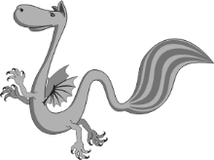

Help Denom the dragon catch the bats in his net by sorting them into **four equal** groups. Remember to first count how many bats there are. Then make sure there is the **same** **number** of bats in each group, find a quarter of the bats…

**Day 2: LO: To recognise, find and name a quarter as one of four equal parts of a quantity**

**Hedgehogs**



12

There are bats

Quarter of =

12

\\BPS2003CDC01\UserFolders$\Staff\along\Downloads\Ritter-bras-leve-800px (1).png\\BPS2003CDC01\UserFolders$\Staff\along\Downloads\Ritter-bras-leve-800px (1).png\\BPS2003CDC01\UserFolders$\Staff\along\Downloads\Ritter-bras-leve-800px (1).png\\BPS2003CDC01\UserFolders$\Staff\along\Downloads\Ritter-bras-leve-800px (1).png\\BPS2003CDC01\UserFolders$\Staff\along\Downloads\Ritter-bras-leve-800px (1).png

There are bats

There are bats

There are bats

4

There are bats

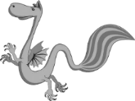

Quarter of =

Quarter of =

Quarter of =

4

Quarter of =