L.O. To be able to recognise, describe, draw and build 3D shapes, including making nets.
Today we will be thinking about 3D shapes. First let us revise the names of 3D shapes and their properties.
- Start by watching the BBC Bitesize video ‘What are the properties of 3D shapes’ https://www.bbc.co.uk/bitesize/topics/zjv39j6/articles/zgqpk2p

3D shapes have faces, edges and vertices.

Faces - A face is a flat or curved surface on a 3D shape. For example a cube has six faces, a cylinder has three and a sphere has just one.

Edges - An edge is where two faces meet. For example a cube has 12 edges, a cylinder has two and a sphere has none.

Vertices- A vertex is a corner where edges meet. The plural is vertices. For example a cube has eight vertices, a cone has one vertex and a sphere has none.
Look at the names of the 3D shapes below. Some of these you may recognise but some you may have not seen before such as a tetrahedron (also known as a triangle-based pyramid) and an octahedron. Look carefully at the shapes, their faces, number of edges and number of vertices.
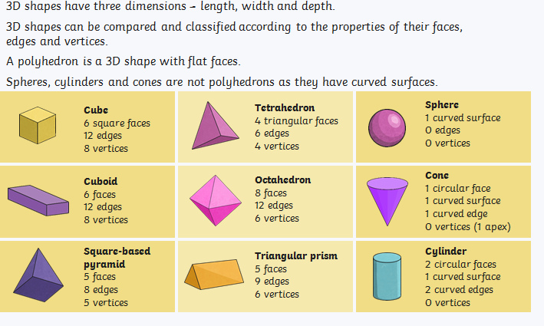
If you need to practise naming 3D shapes and their properties please complete Name the 3D shape activity sheet (try to only look at the answers after you have completed the task).

- Next we will be thinking about the nets of 3D shapes and how we can make them.
Watch the BBC Bitesize video ‘What are nets?’ https://www.bbc.co.uk/bitesize/topics/zt7xk2p/articles/z247tv4#:~:text=The%20net%20of%20a%203D,to%20make%20a%203D%20shape.&text=You%20can%20draw%20a%20net,and%20a%20square%20based%20pyramid.

The net of a 3D shape is what it looks like if it is opened out flat. A net can be folded up to make a 3D shape.

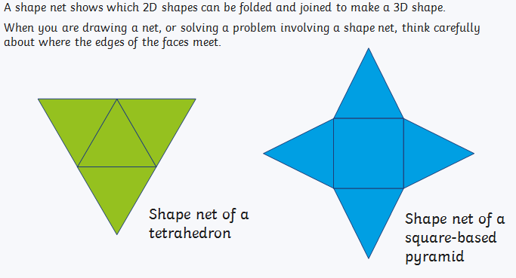

A cube is made from six squares and a tetrahedron is made from four regular triangles (equilateral triangles). Both these 3D shapes are made from only one regular 2D shape. A square based pyramid is made from one square and four regular triangles.

Now use the ‘Cube net’ activity sheet to make a 3D cube. Do not cut off the tabs, use them to stick the edges together. If you are unsure about making a 3D shape using a net please watch the tutorial called ‘Smart learning Tools How to make a 3D cube’ https://www.youtube.com/watch?v=-0bbAfOuh-M
What did you notice about the faces? What did you notice about the position of the faces?
There are actually 11 different nets for a cube!
Tasks
Resources needed: Pencil, ruler and squared paper.
Complete at least one of the set tasks shown below.
Task 1: If you feel unsure about nets please complete Match the 3D net activity sheet and then draw two different cube nets using Squared Paper (count the number of squares to create a regular shape). Remember you can cut out the net to check that you have made a complete, closed cube. Extension: Draw a net to make one of the following 3D shapes: tetrahedron, square based pyramid, cuboid or triangular prism.
Task 2: If you are growing in confidence please complete Nets Text Book activity taken from our class Abacus book. I suggest that you complete your answers on a separate piece of paper because you may wish to cut out the nets to check whether they make a closed 3D shape or not. Draw your tetrahedron using Squared Paper and remember to complete the ‘Think’ by drawing a net that is not possible. Extension: Draw a net of a square based pyramid.
Task 3: Please complete Nets Text Book activity taken from our class Abacus book. I suggest that you complete your answers on a separate piece of paper because you may wish to cut out the nets to check whether they make a closed 3D shape or not. In question 9 I would like you to draw the two nets for a tetrahedron using Squared Paper and remember to complete the Think by drawing a net that is not possible. Extension: Find and then draw all the 11 nets for a cube?
S.C.
1. Have I looked at the properties of the shape to help me name it? Vertices, faces and edges.
2. Have I folded the net along the edges to make a complete 3D shape?
3. Have I checked whether my net has the correct number of faces to make a complete 3D shape and that the faces do not overlap when folded?
4. Have I checked that I have used the correct number of squares to make regular, equal, shapes to create my net?

