Spring Week 3 Maths 3 - Triangles and Rectangles Work
LO To convert units of weight.
Main activity (For all Triangles and Rectangles)
Copy the tables into your book: show your jottings in your book or draw a place value grid to help if necessary.
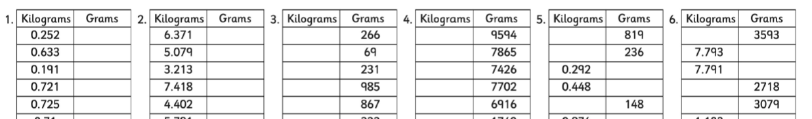
True or False Challenge (Optional) – Make sure you show your working out/ explain your answer. (Don’t just write true or false!!!!)
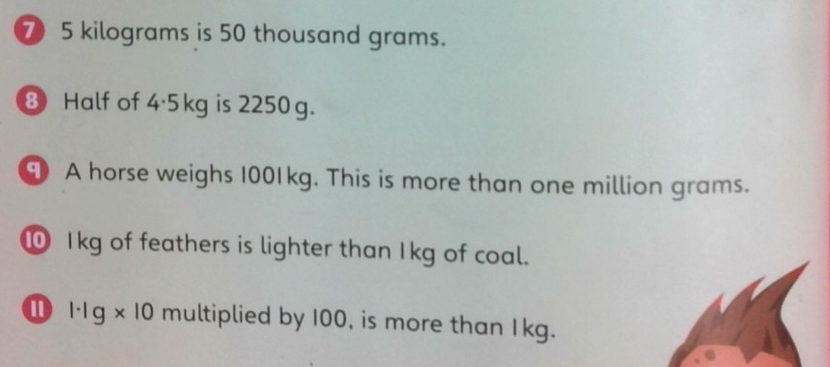

Answers
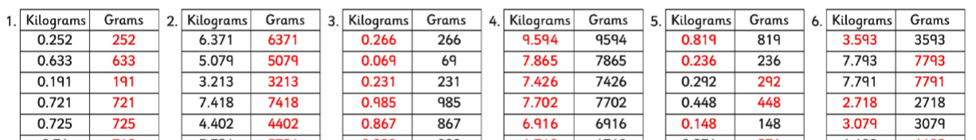
7) False 8) True 9) True 10) False 11) True

