Day 1: L.O: To add by putting the larger number first and counting on (numbers just beyond 20)
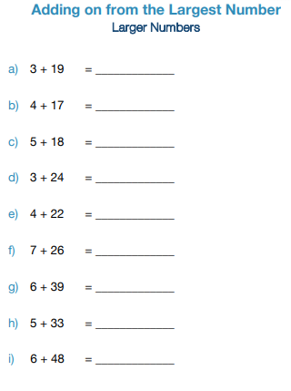

Extension: Have a go at these
5 +26 = _____
6 + 34 = _____
7 + 31 = _____

