Macbeth Week 3 “Daggers for King Duncan”
Answers to Mystery words/phrases:
- Golden Opinions - high opinions about Macbeth’s bravery in battle
- Afeared - frightened
- Peace! - be quiet! Silent!
- Screw your courage to the sticking place – tighten your courage until it is as firm as a screw holding something to the wall!
- This terrible feat – this awful deed
- False face must hide what the false heart must know – I must pretend to be friendly, knowing that I am going to kill King Duncan later tonight

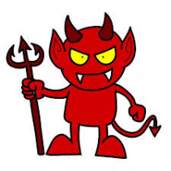
Macbeth Week 4: “All hail, Macbeth! King of Scotland!”

After watching episode 4 of the animation:
- Imagine there is a devil and an angel on each of Macbeth’s shoulders!
- What would the devil tell him to do?
- What would the angel tell him to do?
You are going to write persuasively as the devil or angel or both if you like! Remember you are trying to persuade Macbeth:
- Devil - Kill your best friend, Banquo, because otherwise one of his children will become King, this is the obvious next step after murdering King Duncan, you are now King and need to assert your authority…and keep the crown!!!
- Angel - Let Banquo live, because he is your best friend, you’ve done enough bad things already, you are supposed to be noble and brave, why should you listen to what the witches tell you? Even Lady M thinks it’s a bad idea!!!
I have set up a 2PublishPlus Debate Template in your 2dos called “AngelDevil
Enjoy!!!

