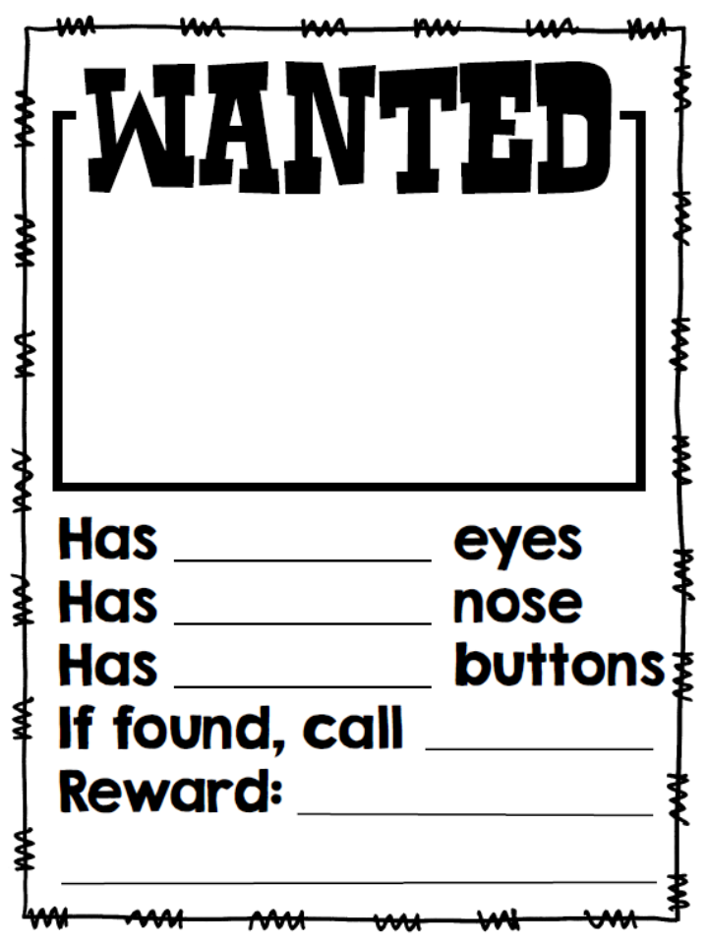

**LO: To write about the appearance and behavior of a traditional tale character**

**CD: 1b**

**Reading Skills: Record and Retrieve**

**Blooms: Understanding**

**LO: To write about the appearance and behavior of a traditional tale character**

**CD: 1b**

**Reading Skills: Record and Retrieve**

**Blooms: Understanding**

**LOST!**

**Name:**

**Last Seen:**

**Description:**