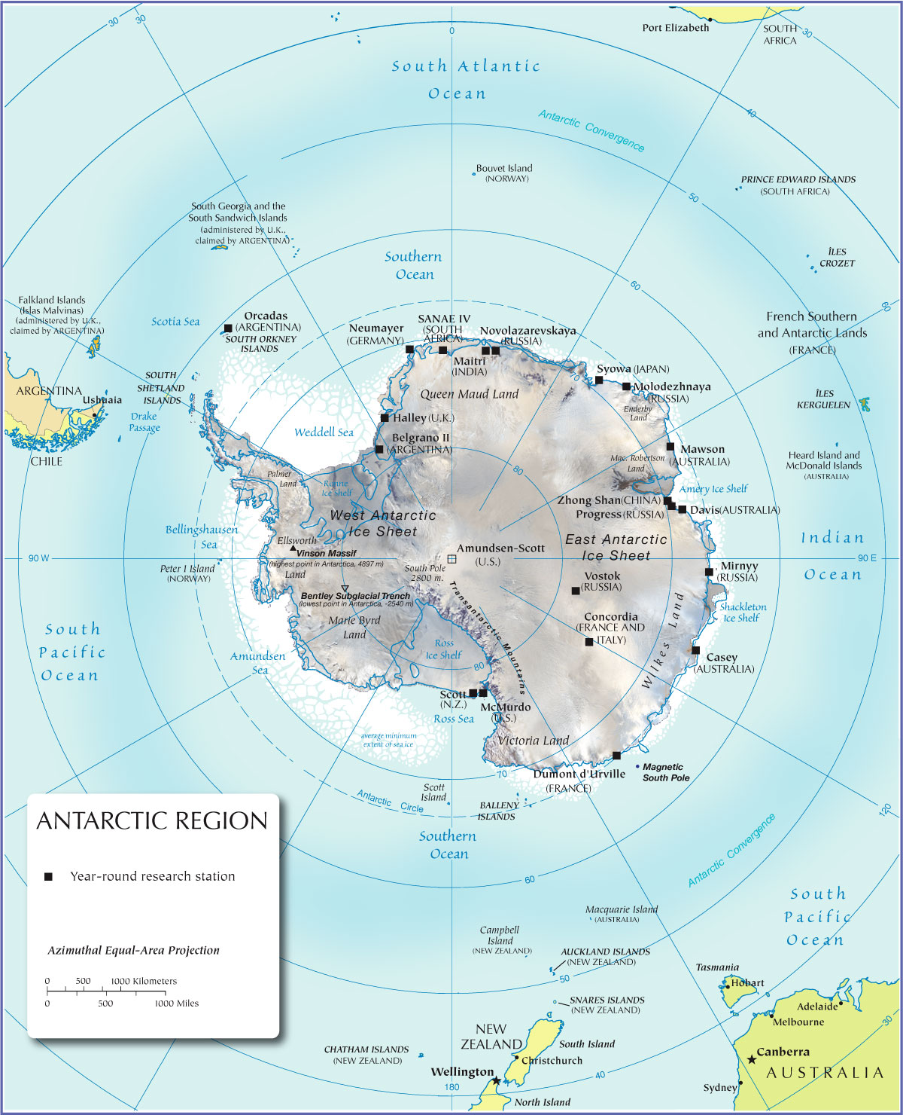

Shackleton’s plan
His boat the Endurance would sail to the Weddell Sea, landing near Vahsal Bay. Two groups of scientists would head out to the east and west to undertake scientific work. Shackleton would the transcontinental group to the march to the south pole. Once they reached the south Pole, they would carry on across the Antarctic to the other side.
Meanwhile, another group of men would sail the ship, the ‘Aurora’ to the Ross Sea and set up camp in the McMurdo sound. From here, they would lay supplies across the Ross Ice Shelf to the foot of the Beardmore Glacier. When Shackleton had passed the South Pole, he would be able to pick up the supplies as he walked across the Ross Ice Shelf. This was important because it meant the Shackleton would not need to carry all the food for the whole transatlantic crossing himself.
The problem was that they had no idea where the Weddell Sea was or what territory they would face when they got there because no one had been there before.

TASKS:
- Mark on the map the route that Shackleton’s expedition hoped to take.

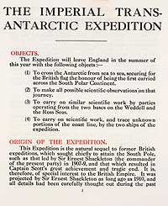

This is the start of the document that Shackleton put together to raise money for his expedition.
Can you add in the details of his plan, writing them as instructions to the crew? Think very carefully about what instructions look like!

- Only look at this when you have finished. Does your route through the Antarctic look like this?

