[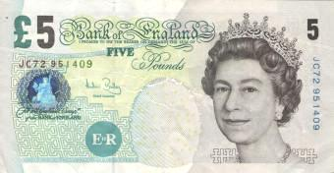](http://www.google.ae/url?sa=i&source=images&cd=&cad=rja&docid=D4Fyo3mgA34G_M&tbnid=8HtIeCrWA0aQkM:&ved=0CAgQjRwwAA&url=http://oldenglishbanknotes.com/five_pound_note_NEW.html&ei=CjO0UYayAs6trAfStYHwCA&psig=AFQjCNErJGfwmV-juxdCk3hYDcsStrPvgQ&ust=1370850442114657)£[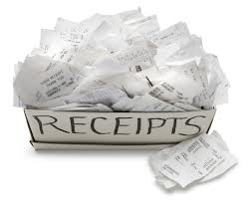](http://www.google.ae/url?sa=i&rct=j&q=&source=images&cd=&cad=rja&docid=yra1WwO6URosTM&tbnid=wFt_BVYxKU_BIM:&ved=0CAUQjRw&url=http://info.milestoneadvisors.net/blog/bid/170352/Segregation-of-Accounting-Duties-Cash-Receipts&ei=wB-0UbymDcumrQerxYCIAg&bvm=bv.47534661,d.bmk&psig=AFQjCNHbopk7cXmLKhTQAeFH7M-sYYXoCA&ust=1370845492238142)

I have £5.00 to pay. Work out the change I will receive after I pay each bill.

Receipt

Pasta £1.99

Apples £1.99

Total £3.98

Change………………………………

Receipt

Chicken £2.67

Rice £1.98

Total £4.65

Change………………………………

Receipt

Caramel £1.97

Pineapple £2.99

Total £4.96

Change………………………………

Receipt

Cereal £3.27

Fish £1.16

Total £4.43

Change………………………………

Receipt

Oranges £1.02

Pear £2.01

Total £3.03

Change………………………………

Receipt

Lolly £2.10

Figs £2.13

Total £4.23

Change………………………………

Receipt

Chocolate £1.02

Apples £1.06

Total £2.08

Change………………………………

Receipt

Jam £1.88

~~Apples £1.02~~

Bread £1.12

Total £3.00

Change………………………………

Receipt

Syrup £1.95

Fig £1.96

Oranges £0.65

Total £4.56

Change………………………………

Receipt

Bananas £1.17

Carrots £1.20

Leeks £1.32

Total £3.69

Change………………………………

Receipt

Butter £3.99

Tin Foil £0.23

Fish £0.12

Total £4.34

Change………………………………

Receipt

Bread £1.23

Rice £1.00

Cake £2.42

Total £4.65

Change………………………………

Receipt

Toffee £1.99

Cereal £0.99

Coffee £0.99

Total £3.97

Change………………………………

Receipt

Coconut £0.99

Soup £1.14

Biscuits £0.09

Total £2.22

Change………………………………

Receipt

Biscuits £1.02

Juice £1.02

Juice £1.02

Total £3.06

Change………………………………

Receipt

Pie £3.04

Plant £1.05

Total £4.09

Change………………………………