[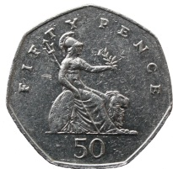](http://www.google.ae/url?sa=i&source=images&cd=&cad=rja&docid=eFx5aNlQQj-bWM&tbnid=ipYGwOwH7r2P7M:&ved=0CAgQjRwwAA&url=http://www.kevinhouston.net/blog/2011/07/curves-of-constant-width-the-50p-story/&ei=GDK0UZyOCMmtrAfD8YC4Aw&psig=AFQjCNFlppj7WzMXyq1AnzDCGNQTfGTRyA&ust=1370850200273398)[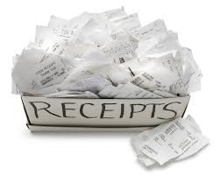](http://www.google.ae/url?sa=i&rct=j&q=&source=images&cd=&cad=rja&docid=yra1WwO6URosTM&tbnid=wFt_BVYxKU_BIM:&ved=0CAUQjRw&url=http://info.milestoneadvisors.net/blog/bid/170352/Segregation-of-Accounting-Duties-Cash-Receipts&ei=wB-0UbymDcumrQerxYCIAg&bvm=bv.47534661,d.bmk&psig=AFQjCNHbopk7cXmLKhTQAeFH7M-sYYXoCA&ust=1370845492238142)

I have 50p to pay. Work out the change I will receive after I pay each bill.

Receipt

Toffee 12p

Cereal 5p

Coffee 11p

Total 28p

Change………………………………

Receipt

Bananas 15p

Carrots 3p

Leeks 22p

Total 40p

Change………………………………

Receipt

Coconut 12p

Soup 7p

Biscuits 9p

Total 28p

Change………………………………

Receipt

Biscuits 5p

Juice 12p

Juice 12p

Total 29p

Change………………………………

Receipt

Pasta 11p

Apples 7p

Sauce 14p

Total 32p

Change………………………………

Receipt

Chicken 12p

Rice 8p

Cake 11p

Total 31p

Change………………………………

Receipt

Caramel 4p

Pineapple 6p

Turkey 14p

Total 24p

Change………………………………

Receipt

Cereal 12p

Fish 3p

Crackers 12p

Total 27p

Change………………………………

Receipt

Pie 7p

Plant 6p

Beef 10p

Total 23p

Change………………………………

Receipt

Oranges 9p

Pear 1p

Celery 18p

Total 29p

Change………………………………

Receipt

Chocolate 5p

Apples 6p

Carrots 11p

Total 22p

Change………………………………

Receipt

Lolly 2p

Figs 11p

Flour 12p

Total 25p

Change………………………………

Receipt

Jam 4p

Apples 16p

Bread 19p

Total 39p

Change………………………………

Receipt

Syrup 17p

Fig 1p

Oranges 12p

Total 30p

Change………………………………

Receipt

Butter 3p

Tin Foil 16p

Fish 17p

Total 36p

Change………………………………

Receipt

Bread 2p

Rice 16p

Cake 23p

Total 41p

Change………………………………