[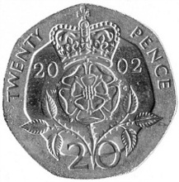](http://www.google.ae/url?sa=i&source=images&cd=&cad=rja&docid=Lgke_cjNSYOwuM&tbnid=FhqR_Y5dBtkOYM:&ved=0CAgQjRwwAA&url=http://www.grippy.co.uk/tyre-news/2011/10/would-your-tyres-pass-a-police-check/&ei=ky60UamjJorzrQea5oDIBw&psig=AFQjCNFgTRexLlsHZ8oSOcU9VHvxQSPRaQ&ust=1370849299700511)[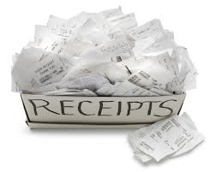](http://www.google.ae/url?sa=i&rct=j&q=&source=images&cd=&cad=rja&docid=yra1WwO6URosTM&tbnid=wFt_BVYxKU_BIM:&ved=0CAUQjRw&url=http://info.milestoneadvisors.net/blog/bid/170352/Segregation-of-Accounting-Duties-Cash-Receipts&ei=wB-0UbymDcumrQerxYCIAg&bvm=bv.47534661,d.bmk&psig=AFQjCNHbopk7cXmLKhTQAeFH7M-sYYXoCA&ust=1370845492238142)

I have 20p to pay. Work out the change I will receive after I pay each bill.

Receipt

Jam 4p

Apples 16p

Total 20p

Change………………………………

Receipt

Syrup 17p

Fig 1p

Total 18p

Change………………………………

Receipt

Butter 3p

Tin Foil 16p

Total 19p

Change………………………………

Receipt

Bread 2p

Rice 16p

Total 20p

Change………………………………

Receipt

Toffee 12p

Cereal 5p

Total 17p

Change………………………………

Receipt

Bananas 15p

Carrots 3p

Total 18p

Change………………………………

Receipt

Coconut 12p

Soup 7p

Total 19p

Change………………………………

Receipt

Biscuits 5p

Juice 12p

Total 17p

Change………………………………

Receipt

Pasta 11p

Apples 7p

Total 18p

Change………………………………

Receipt

Chicken 12p

Rice 8p

Total 20p

Change………………………………

Receipt

Caramel 4p

Pineapple 6p

Total 10p

Change………………………………

Receipt

Cereal 12p

Fish 3p

Total 15p

Change………………………………

Receipt

Oranges 9p

Pear 1p

Total 10p

Change………………………………

Receipt

Pie 7p

Plant 6p

Total 13p

Change………………………………

Receipt

Lolly 2p

Figs 11p

Total 13p

Change………………………………

Receipt

Chocolate 5p

Apples 6p

Total 11p

Change………………………………