Learn – Area of shapes
This Wednesday in maths we will be finding the area of triangles and parallelograms. Please read through the information below and watch the videos that I have suggested to help develop your understanding.
Area of rectangles
To work out the area of a rectangle, you need the formula:
area = length × width
You have to multiply the length of the rectangle by the width.
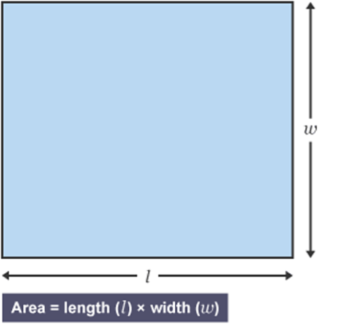
Let's look at an example.
What is the area of this rectangle?
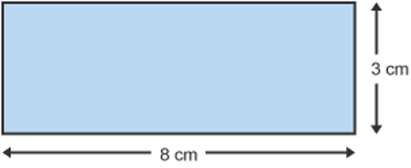
Area = length × width
Area = 8 cm × 3 cm
Area = 24 cm²
The answer is 24 cm².
Area of parallelograms
To work out the area of a parallelogram, you need the formula:
area = base × height
You have to multiply the base of the parallelogram by the perpendicular height (often shown with a dotted line or arrow), not the sloping height.
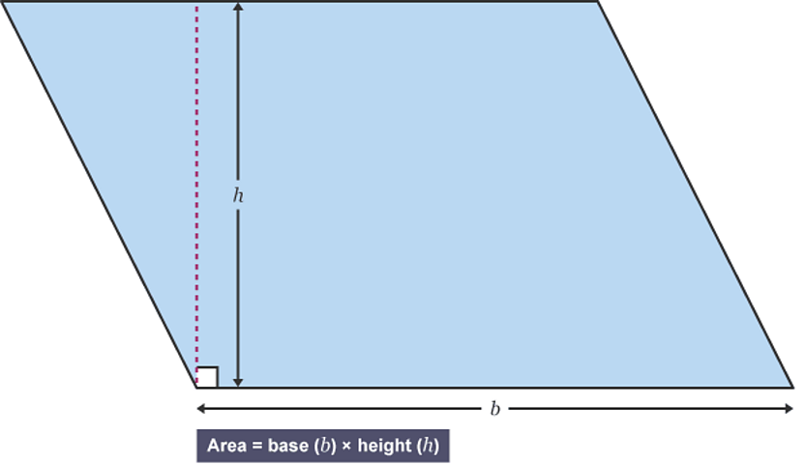
.
Let's look at an example.
What is the area of this parallelogram?
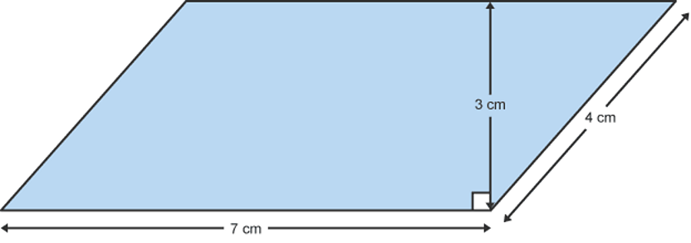
Area = base × height
Area = 7 cm × 3 cm
Area = 21 cm²
The answer is 21 cm².
Watch the following video to help reinforce your understanding of finding the area of a parallelogram. https://www.bbc.co.uk/bitesize/topics/zrf3cdm/articles/zgkh97
Area of triangles
Look at the triangle below.
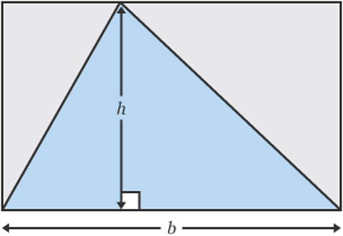
If you multiply the base by the perpendicular height (length × width), you get the area of a rectangle. The area of the triangle is half the area of the rectangle.
So, to find the area of a triangle, multiply the base by the height and divide by two. The formula is:
Area = (base × height) ÷ 2
You might also see:
Area = 0.5 × (base × height)
Let's look at an example.
What is the area of this triangle?
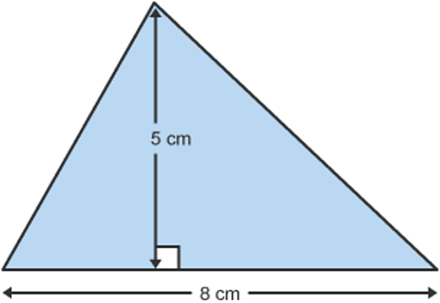
Area = (base × height) ÷ 2
Area = (8 cm × 5 cm) ÷ 2
Area = 40 cm ÷ 2
Area = 20 cm²
The answer is 20 cm².
When calculating the area of a triangle remember to use the height and not the measurement of the sloping sides!
Watch the following video to reinforce your understanding. https://www.bbc.co.uk/bitesize/topics/zjbg87h/articles/zsqxfcw
Tasks
I have split the tasks into three sections and you will need to choose which section to complete depending on how confident you are with finding the area of triangles and parallelograms. I am only expecting you to complete one of the tasks (if you would like to do more then go for it) so if you are not confident then work on the activities in Task 1, growing in confidence complete Task 2 and if you require more of a challenge then complete the activities in Task 3.
Task 1 – Introduction
Please complete ‘Calculating the area of triangles 6.8a’ and ‘Area of parallelograms Activity sheet’. The questions in the parallelogram worksheet become harder from question 6, in these questions you have been given the area and one of the side measurements (either the base or the height). You will need to calculate the missing side measurement so to do this look at the area and then divide by the side measurement e.g. look at question 6 the area is 42cm² and the height is 6cm so 42cm² ÷ 6cm = 7cm therefore the base of the parallelogram is 7cm. This calculation is the inverse of the calculation you performed in the earlier questions.
I have included the answers to this activity so no peeking until the end!!
Task 2 – Growing confidence
Please complete ‘Area of Parallelograms Activity Sheet’. The questions in the parallelogram worksheet become harder from question 6, in these questions you have been given the area and one of the side measurements (either the base or the height). You will need to calculate the missing side measurement so to do this look at the area and then divide by the side measurement e.g. look at question 6 the area is 42cm² and the height is 6cm so 42cm² ÷ 6cm = 7cm therefore the base of the parallelogram is 7cm. This calculation is the inverse of the calculation you performed in the earlier questions.
Then complete ‘Area of Triangles Activity Sheet’. The questions in this activity sheet become more tricky from question 16. You have been given the area of the triangle and either the base or height measurement, you must calculate the other missing measurement. To do this start with the area, multiply by two and then divide by the measurement you have been given either the base or the height e.g. question 16 the area is 14cm² and the base is 7cm so 14cm² x 2 = 28cm² then 28cm² ÷ 7cm = 4cm. This calculation is the inverse of the calculation you performed in the earlier questions.
I have included the answers to these activities so no peeking until the end!!
Extension (optional) – Complete ‘Resource Sheet 976b’. Make sure you look carefully at the shape to decide which formula to use.

Task 3 - Challenge
Complete ‘Resource Sheet 976b’. Make sure you look carefully at the shape to decide which formula to use.
Next use worksheet ‘Area of Parallelograms Activity Sheet’ answer questions 6 to 10 and worksheet ‘Area of Triangles Activity Sheet’ questions 16 to 20. If you are stuck look at the instructions in the Task 2 section to help.
Finally work through the ‘Mastery Checkpoint Area of Shapes’, please read the questions carefully.

