  - 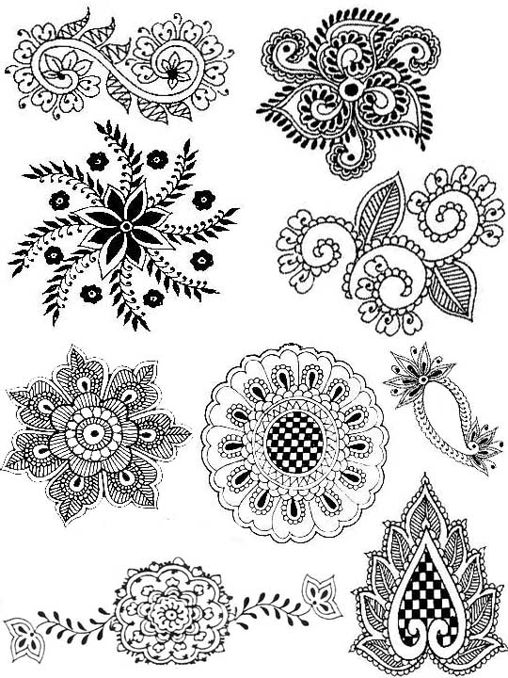
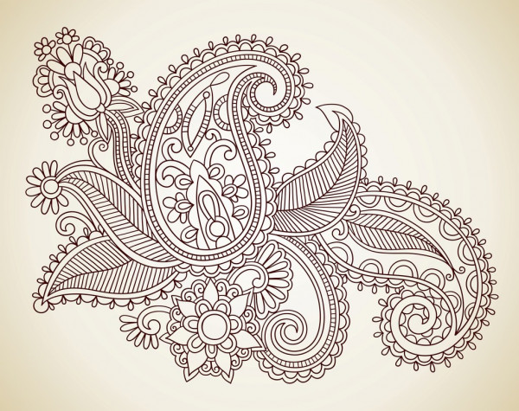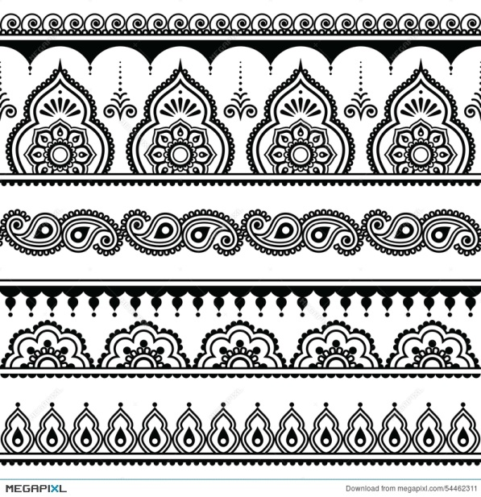
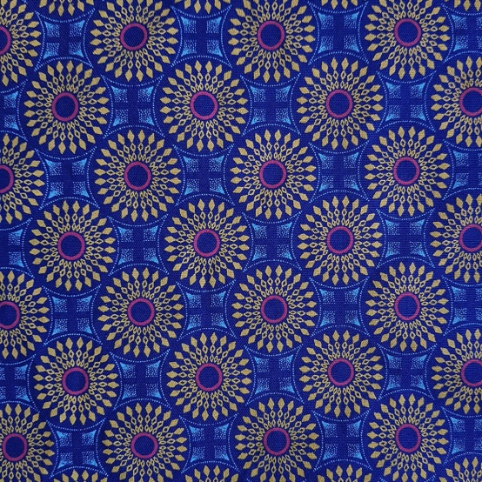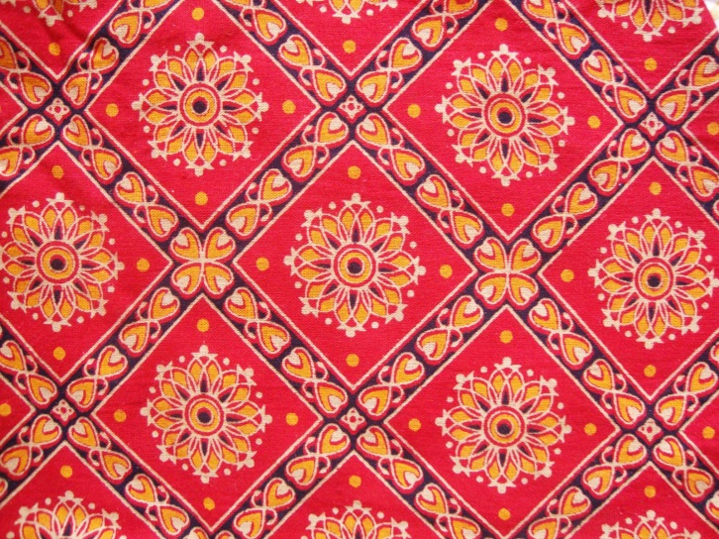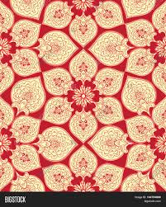
Task 1
The images you see above are all examples of Indian patterns. Take a blank piece of paper and record the words ‘Indian Patterns’ in a bubble in the centre of the page. Then around the bubble thought storm all your observations. Use the questions below to guide your ideas.
What do I notice about the patterns?
How could I describe the patterns?
What do I think inspired the creation of these patterns?
Name the main colours used in these designs. Why do I think these colours have been used in the Indian patterns?
Can I explain what is meant by ‘Cultural Colours’?
How do these patterns make me feel?

Task 2
Find a new blank piece of paper and a sharp pencil and start sketching some of the patterns. You can choose to sketch the whole pattern or just part of the design. Alter the size of the sketches and remember to add as much detail as you can see. Find some colouring pencils and try to match the tone to the example you are studying, then use them to add colour to some of your sketches. Your final page should be covered with your drawings. If you can, explore some other Indian patterns in books or on the internet (ask permission first) and add them to your sketch work.

